ALDEHYDES, KETONES AND CARBOXYLIC ACIDS

CHAPTER OVERVIEW AND IMPORTANCE
The chapter on Aldehydes, Ketones, and Carboxylic Acids is highly significant for both JEE Main and Advanced. It is a large chapter where each section is studied in detail. Historically, this chapter is guaranteed to provide a minimum of two questions in the examination. The session focuses on all important reactions and topics from a JEE and board exam perspective.

PREREQUISITES
A strong foundation in previous organic chemistry chapters is essential to understand this topic effectively. Specifically, students should have already completed Haloalkanes and Haloarenes, as well as Alcohols, Phenols, and Ethers. Many reactions in this chapter have appeared in these earlier sections.

CARBONYL GROUP DEFINITIONS
The central functional group discussed in this chapter is the carbonyl group, which is a carbon double-bonded to an oxygen (C=O).
Aldehydes are defined as compounds where the carbonyl group has one alkyl group (R) and one hydrogen atom (H) attached to the carbon (R-CHO).
Ketones are defined as compounds where the carbonyl group has alkyl groups (R) attached to both sides of the carbon (R-CO-R).

ACID DERIVATIVES
Beyond aldehydes and ketones, the chapter introduces carboxylic acids and their various derivatives. These derivatives are formed by substituting the groups attached to the carbonyl carbon. Common derivatives mentioned include:
- Acid Chlorides
- Esters
- Anhydrides
- Amides

ELECTRONIC NATURE AND STRUCTURE
The carbonyl group is fundamentally polar due to the difference in electronegativity between carbon and oxygen. Oxygen is significantly more electronegative than carbon, which results in oxygen carrying a partial negative charge (δ⁻) and carbon carrying a partial positive charge (δ⁺).
The carbon atom serves as an electrophilic center because of its positive charge density.
The oxygen atom serves as a nucleophilic center because of its negative charge density.

REACTION SITE PROPERTIES
- Carbonyl Carbon: Electrophilic center (δ⁺)
- Carbonyl Oxygen: Nucleophilic center (δ⁻)

JEE ADVANCED INSIGHTS
UNDERSTANDING NUCLEOPHILIC ATTACK
For Advanced level problems, remember that the electrophilic nature of the carbon is the driving force for most mechanisms in this chapter. If you can identify the nucleophile in a reaction, you can predict its point of attachment on the carbonyl group. Advanced questions often combine this with acid derivatives like esters or amides to test your understanding of leaving groups and substitution versus addition.

--------------------------------------------------------------------------------
METHOD OF PREPARATION OF ALDEHYDES AND KETONES (COMMON METHODS FOR BOTH)

OXIDATION OF ALCOHOLS {alcohol chapter m h}
Preparation of aldehydes and ketones from alcohols depends on the degree of the alcohol and the strength of the oxidizing agent used.
- 1° Alcohols: Oxidized to Aldehydes using mild oxidizing agents like PCC (Pyridinium Chlorochromate). Strong agents would continue the oxidation to carboxylic acids.
- 2° Alcohols: Oxidized to Ketones. Since ketones are resistant to further oxidation, both mild and strong oxidizing agents can be used.
- 3° Alcohols: These do not undergo oxidation under normal conditions because they lack an alpha-hydrogen atom.

CATALYTIC DEHYDROGENATION {alcohol m tha}
Pass alcohol vapors over red-hot Copper (Cu) at 573 K.
- 1° Alcohol: Forms Aldehyde (e.g., R-CH₂OH → R-CHO + H₂).
- 2° Alcohol: Forms Ketone (e.g., R-CH(OH)-R → R-CO-R + H₂).
- (Exception) 3° Alcohol: Undergoes elimination (dehydration) instead of oxidation/dehydrogenation to form an Alkene.

OZONOLYSIS OF ALKENES {Imp, hydrocarbon m bhi tha}
Alkenes react with O₃ in CCl₄ to form an Ozonide intermediate (a five-membered cyclic structure).
The Ozonide is then subjected to reductive workup using Zinc and Water (Zn/H₂O).
The products depend on the structure of the alkene:
- Symmetrical/Monosubstituted carbons: Lead to Aldehydes.
- Disubstituted carbons: Lead to Ketones.
- Short Trick: Break the C=C double bond, remove the bond entirely, and attach an Oxygen atom (=O) to each formerly double-bonded carbon.
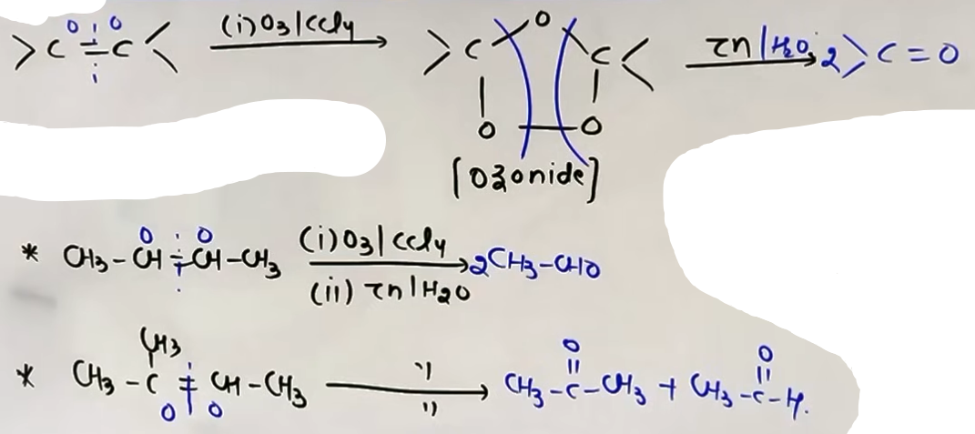
[ # ulte question bhi aate h jaise ye aldehyde or ketone kis alkene se baha hoga, jin carbon se =O jura h unhe tora aur dono carbon ko aapas m double bond se jor diya ]

HYDROLYSIS OF ALKYNES (HYDRATION)
Alkynes undergo hydration in the presence of Hg²⁺/H⁺ (Reagents: HgSO₄ and H₂SO₄).
- Mechanism: Markovnikov addition of water to the C≡C bond results in an "Enol" intermediate.
- Tautomerism: The unstable Enol quickly tautomerizes into the stable "Keto" form (Aldehyde or Ketone).
- Alkyne Specificity:
- Ethyne (Acetylene) is the only alkyne that produces an aldehyde (Acetaldehyde).
- All other higher alkynes (Propyne, Butyne, etc.) yield Ketones because Markovnikov's rule places the Oxygen on the internal carbon.
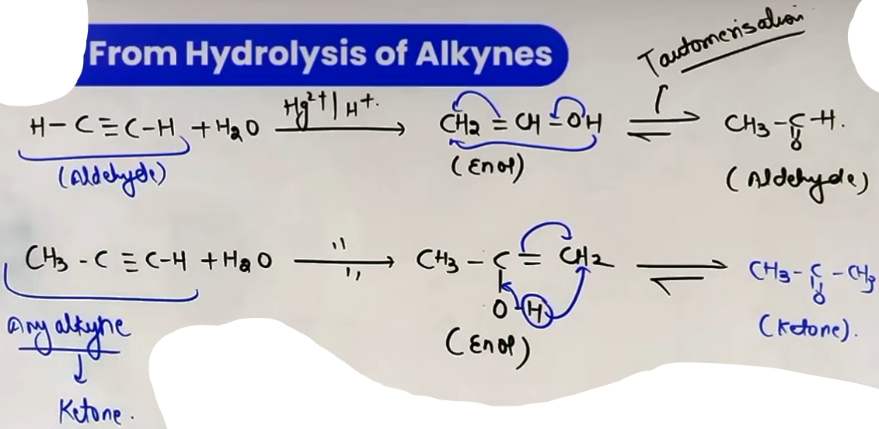
INTUITION AND CONCEPTUAL UNDERSTANDING
VISUALIZING THE OXIDATION TRAP
Think of 1° and 2° alcohols as having a "removable" hydrogen on the carbon and the oxygen. 3° alcohols have no hydrogen on the central carbon, so the "bridge" to form a double bond to oxygen is missing. Instead of forcing an oxidation that cannot happen, the molecule "sweats out" a full water molecule (dehydration) to form an alkene when heated with Copper.

FORMULA SHEET
REAGENTS AND PRODUCTS
- PCC: R-CH₂OH → R-CHO
- Cu/573 K: 1° Alcohol → Aldehyde; 2° Alcohol → Ketone; 3° Alcohol → Alkene
- O₃, then Zn/H₂O: C=C → C=O + O=C
- Hg²⁺/H⁺, H₂O: R-C≡C-H → R-CO-CH₃ (Ketone)
- Hg²⁺/H⁺, H₂O (Ethyne): H-C≡C-H → CH₃CHO (Acetaldehyde)

JEE ADVANCED INSIGHTS
OZONOLYSIS OF CYCLIC ALKENES
In JEE Advanced, ozonolysis of cyclic alkenes is a common trap. If you cut the C=C bond within a ring, the ring opens up, resulting in a single long chain with two carbonyl groups at the ends. Always number your carbons to ensure you do not lose any during the ring-opening process.

HIGH-YIELD REVISION SHEET
MUST REMEMBER
- Ozonolysis "Short Trick": Break C=C, add O to both sides.
- Ozonolysis "Reverse Trick": Remove =O from both, join with C=C.
- Cu at 573 K: 1° -> Aldehyde, 2° -> Ketone, 3° -> Alkene.
- Hg²⁺/H⁺ Hydration: Ethyne -> Acetaldehyde; All others -> Ketones.
- PCC: Best reagent for 1° Alcohol to Aldehyde conversion.

LAST-MINUTE REVISION POINTS
- Ozonolysis of Benzene yields 3 moles of Glyoxal (CHO-CHO).
- Red-hot Copper tube temp is 573 K.
- Hydration of alkynes follows Markovnikov's rule.
- Tautomerism: Enol form (C=C-OH) to Keto form (CH-C=O).

--------------------------------------------------------------------------------
METHODS OF PREPARATION OR ALDEHYDES ONLY

ROSENMUND REDUCTION {Imp}
# no rearrangement no nothing :)
This method converts acid halides (acyl chlorides) into aldehydes using Hydrogen gas (H₂) in the presence of a Palladium (Pd) catalyst supported on Barium Sulphate (BaSO₄).
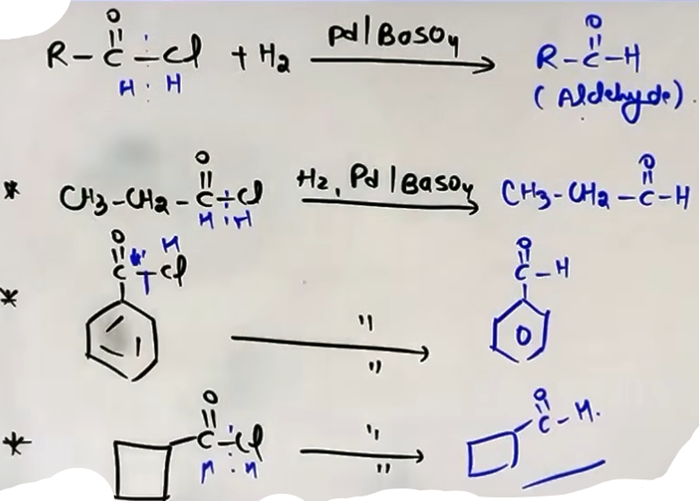
The combination of Pd-BaSO₄ is often called Lindlar's catalyst. The BaSO₄ acts as a "poison" to the catalyst, which prevents the reduction from continuing past the aldehyde stage into an alcohol.
This reaction works for both aliphatic and aromatic acid chlorides.
Short trick: Break the C-Cl bond and add one H to Carbon and one H to Chlorine.

STEPHEN REACTION {V. Imp}
This involves the reduction of cyanides (nitriles) to imines using Stannous Chloride (SnCl₂) and Hydrochloric acid (HCl).
The SnCl₂/HCl mixture provides nascent hydrogen for the reduction.
The resulting imine (R-CH=NH) is then hydrolyzed with water to form the final aldehyde.
Short trick for hydrolysis: Replace the -C≡N group with an -CHO atom.
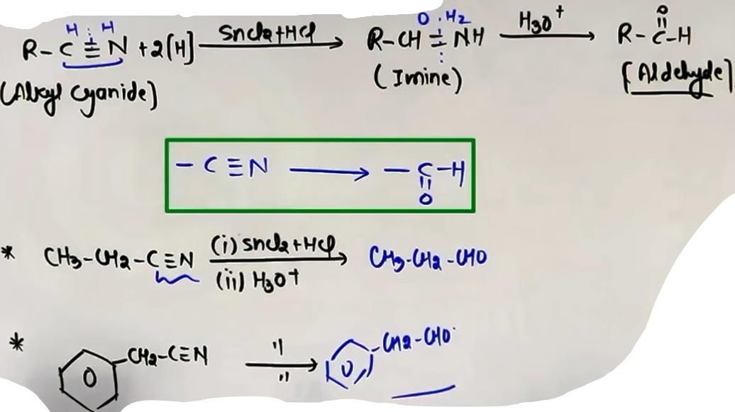
REDUCTION WITH DIBAL-H
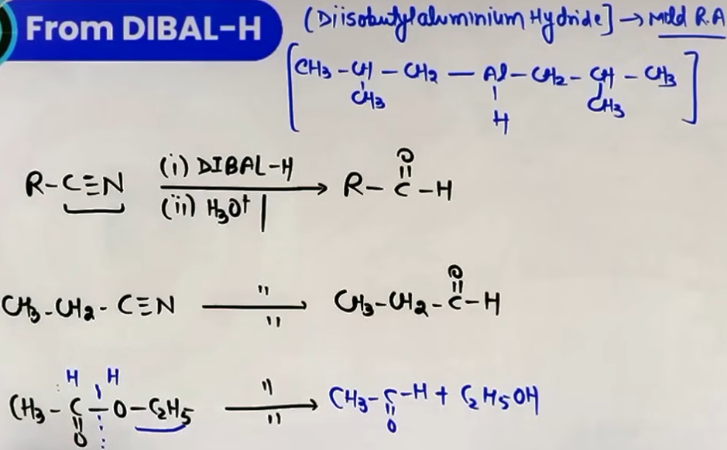
Diisobutylaluminium hydride (DIBAL-H / AlH(i-Bu)₂) is used for the selective reduction of cyanides (nitriles) and esters into aldehydes.
The reaction is performed at low temperatures (e.g., -78°C). # temp not imp.
DIBAL-H is highly selective; it will reduce a nitrile or ester group without affecting C=C double bonds elsewhere in the molecule.
For esters, the bond between the carbonyl carbon and the alkoxy oxygen (C-O) is broken and replaced with a C-H bond.

“Benzaldehyde from Aromatic Hydrocarbons {ban aldehyde hi raha h but aromatic}”
ETARD REACTION
This reaction converts toluene into benzaldehyde using Chromyl Chloride (CrO₂Cl₂).
Chromyl chloride acts as a mild oxidizing agent.
A brown chromium complex is formed as an intermediate, which yields benzaldehyde upon hydrolysis.
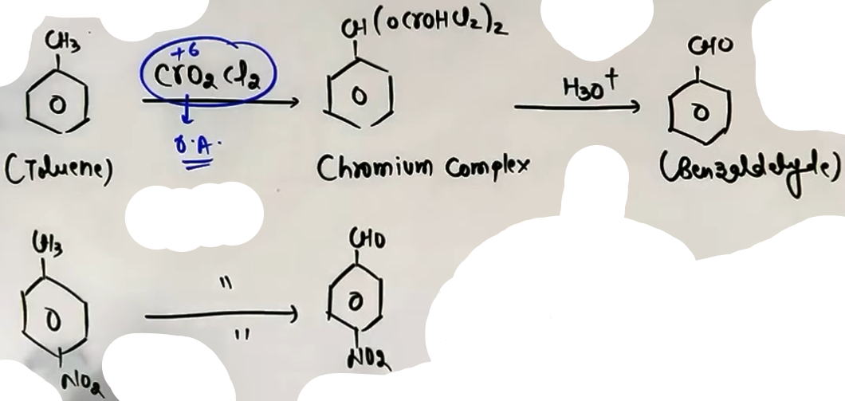
OXIDATION WITH CHROMIC OXIDE (CrO₃)
Toluene or substituted toluenes are treated with chromic oxide in acetic anhydride.
This forms a benzylidene diacetate intermediate, which prevents further oxidation to a carboxylic acid.
Hydrolysis of this intermediate with aqueous acid produces benzaldehyde.
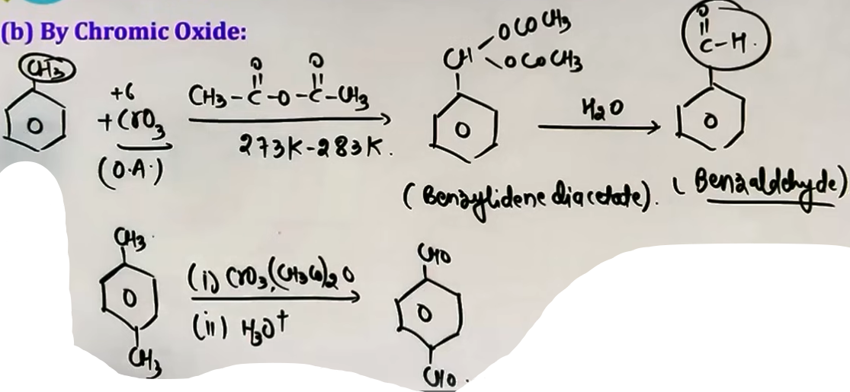
SIDE CHAIN CHLORINATION
This is the commercial (industrial) method for preparing benzaldehyde.
Toluene undergoes side-chain chlorination with Chlorine (Cl₂) in the presence of sunlight (hν) to produce benzal dichloride.
Hydrolysis of benzal dichloride yields benzaldehyde.
Mechanism involves the formation of an unstable gem-diol intermediate which loses water.
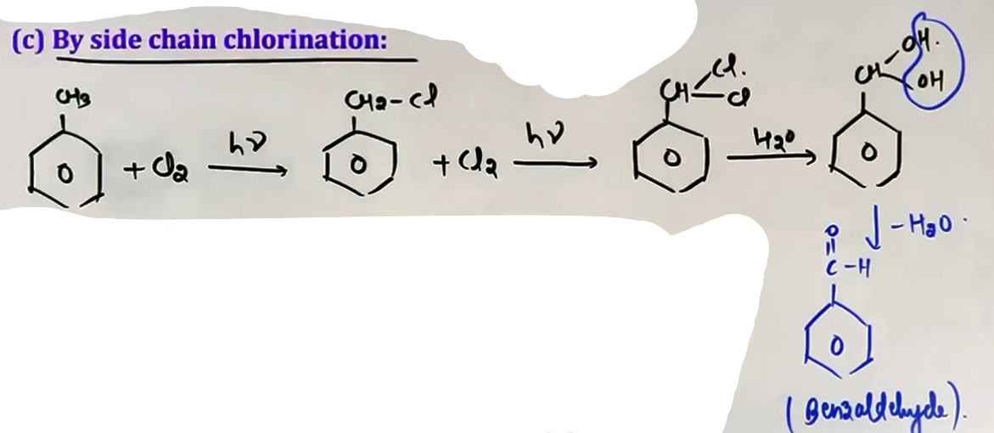
GATTERMANN-KOCH REACTION
Benzene or its derivatives are treated with Carbon Monoxide (CO) and Hydrogen Chloride (HCl) in the presence of anhydrous Aluminium Chloride (AlCl₃) or Cuprous Chloride (CuCl).
This results in the formation of benzaldehyde or substituted benzaldehydes.
This is an Electrophilic Aromatic Substitution Reaction (EASR) where a formyl cation-like species acts as the electrophile.
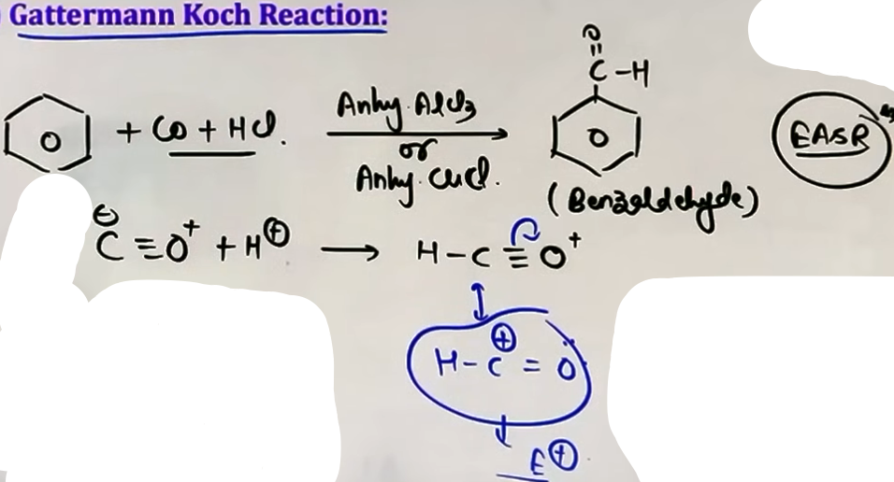
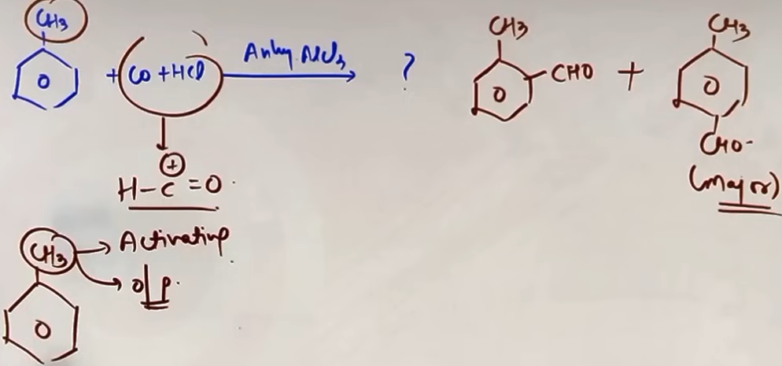

INTUITION AND CONCEPTUAL UNDERSTANDING
CONTROLLED REDUCTION
- The primary challenge in aldehyde preparation is stopping the reaction before it reaches the alcohol stage.
- In Rosenmund, we use a "poisoned" catalyst (BaSO₄) to reduce the catalyst's power.
- In DIBAL-H, we use low temperatures and a bulky reagent to slow down the process so it stops at the aldehyde.

REAGENT SUMMARY TABLE
+------------------+---------------+---------------------------+--------------+
| Reaction Name | Reactant | Main Reagents | Product |
+------------------+---------------+---------------------------+--------------+
| Rosenmund | R-COCl | H₂, Pd-BaSO₄ | R-CHO |
| Stephen | R-CN | SnCl₂, HCl then H₂O | R-CHO |
| DIBAL-H | R-CN or Ester | DIBAL-H, Low Temp | R-CHO |
| Etard | Toluene | CrO₂Cl₂, CS₂ then H₂O | Benzaldehyde |
| CrO₃ Method | Toluene | CrO₃, Acetic Anhydride | Benzaldehyde |
| Side Chain Cl | Toluene | Cl₂, hv then H₂O | Benzaldehyde |
| Gattermann-Koch | Benzene | CO, HCl, AlCl₃/CuCl | Benzaldehyde |
+-----------------------------------------------------------------------------+
JEE ADVANCED INSIGHTS
DIBAL-H STOICHIOMETRY :-
DIBAL-H is a mild reducing agent. Unlike LiAlH₄ which is a strong "bomb," DIBAL-H acts as a "sniper" targeting specific groups at low temperatures.
GATTERMANN-KOCH ELECTROPHILE :-
The electrophile in Gattermann-Koch is the [CHO]⁺ cation species generated from CO and HCl. This is why it follows the standard rules of Electrophilic Aromatic Substitution (EAS).

COMMON MISTAKES AND TRAPS
Mistake | Why Students Make It | Correct Approach
Stephen Reaction Medium | Thinking it is just snCl₂ | Acidic medium (HCl) is mandatory.
Alkyl Chain Length in Etard | Trying to oxidize long chains | Etard is specific for methyl groups.
Gattermann-Koch vs Gattermann | Confusing name reactions | Koch involves CO/HCl for Benzaldehyde.

HIGH-YIELD REVISION SHEET
MUST REMEMBER
- Rosenmund: H₂/Pd-BaSO₄ turns Acid Chlorides to Aldehydes.
- Stephen: SnCl₂/HCl turns Cyanides to Aldehydes via Imines.
- DIBAL-H: Best for Ester/Nitrile to Aldehyde without hitting C=C.
- Etard: Chromyl Chloride is the reagent for Benzaldehyde.
- Gattermann-Koch: Adds -CHO to Benzene using CO and HCl.

LAST-MINUTE REVISION POINTS
- Lindlar's catalyst (Pd-BaSO₄) prevents alcohol formation.
- Nascent hydrogen is the reducing species in Stephen reaction.
- -78°C is the typical temperature for DIBAL-H selectivity.
- Side chain chlorination needs two Cl atoms on the carbon to form an aldehyde after hydrolysis.
- In Gattermann-Koch, CuCl acts as a co-catalyst with AlCl₃.
--------------------------------------------------------------------------------
METHODS OF PREPARATION OR KETONES ONLY

FRIEDEL-CRAFTS ACYLATION
This reaction is a method to prepare aromatic ketones (Phenones). Benzene or its derivatives react with an acid chloride (R-COCl) or an acid anhydride in the presence of a Lewis acid catalyst like anhydrous AlCl₃.
The mechanism is Electrophilic Aromatic Substitution (EAS). The Lewis acid AlCl₃ reacts with the acid chloride to generate the acylium ion electrophile (R-CO⁺).
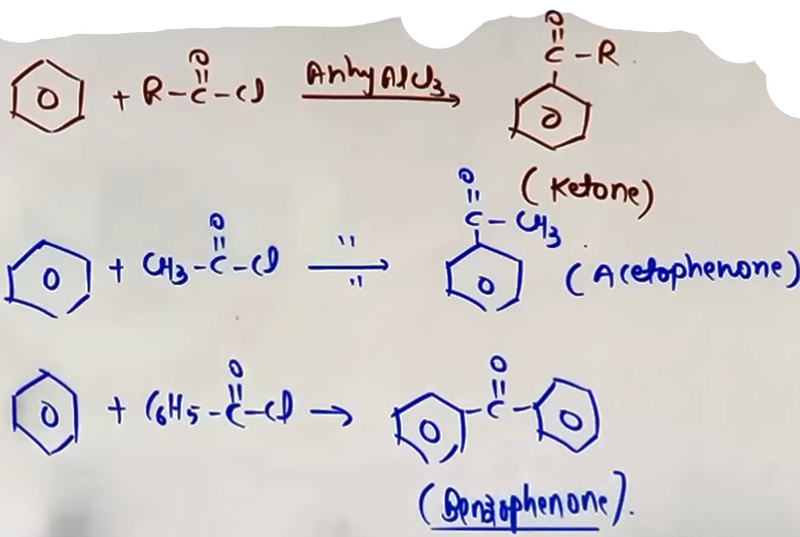Figure 1: Acetophenone Benzophenone ye naame dhyan m rakhna
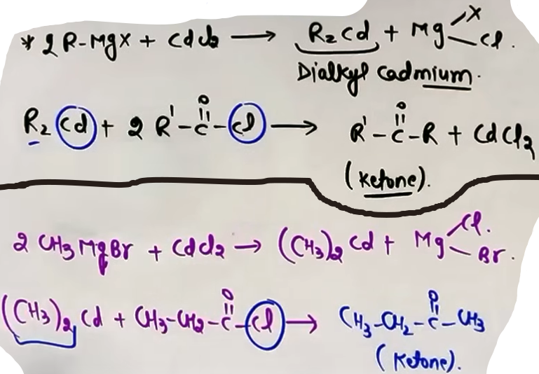
DIALKYL CADMIUM METHOD
This is an excellent method to prepare ketones from acyl chlorides while avoiding the formation of tertiary alcohols.
Cadmium reagents are less reactive than Grignard reagents. This lower reactivity is the key: they are strong enough to attack the acid chloride but too weak to attack the resulting ketone.
Preparation of reagent:
2R-MgX + CdCl₂ → R₂Cd (diaklyl cadmium) + 2Mg(X)Cl
Reaction with acyl chloride:
2R'-COCl + R₂Cd → 2R'-CO-R + CdCl₂

GRIGNARD REAGENTS WITH CYANIDES (NITRILES)
Grignard reagents (R'-MgX) add to the C-N triple bond of nitriles (R-CN) to form an imine salt intermediate.
Mechanism:
1. Nucleophilic attack: The R'- group of the Grignard reagent attacks the electrophilic carbon of the nitrile.
2. Formation of imine salt: [R-C(R')=N-MgX].
3. Hydrolysis: The imine salt is hydrolyzed with H₃O⁺ to yield the ketone and ammonia (NH₃).
R-CN + R'-MgX (Dry Ether) → R-C(R')=N-MgX (Hydrolysis) → R-CO-R'
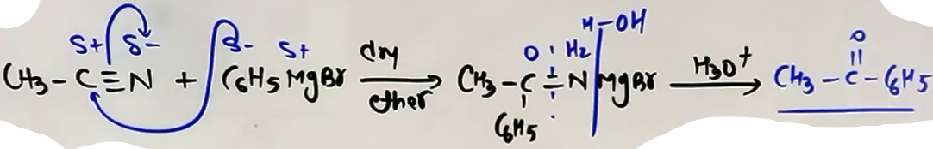
GRIGNARD REAGENTS WITH ACID DERIVATIVES
Acid derivatives like acyl chlorides, esters, and anhydrides (Z) react with Grignard reagents via a Nucleophilic Addition-Elimination mechanism.
Reaction steps:
1. Nucleophilic Addition: The Grignard reagent (R'-MgX) attacks the carbonyl carbon.
2. Elimination: The leaving group (Z) leaves, re-forming the C=O bond to produce a ketone.
Crucial Stoichiometry:
If 1 equivalent of Grignard reagent is used, the reaction can be stopped at the ketone stage.
If 2 equivalents are used, the resulting ketone reacts again to form a tertiary (3°) alcohol.
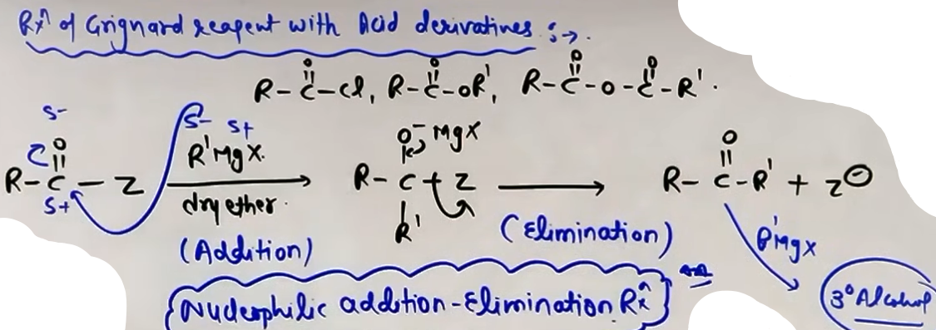
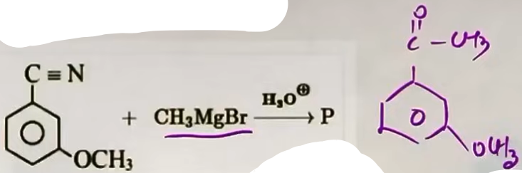Figure 2: # -OCH₃ se koi lena dena nahi
INTUITION AND CONCEPTUAL UNDERSTANDING
- MENTAL MODEL FOR CADMIUM REAGENTS
Think of the cadmium reagent as a "gentle" version of the Grignard reagent. A Grignard reagent is like a heavy hammer that breaks through both acid chlorides and ketones. A cadmium reagent is like a specialized tool that only works on the more reactive acid chloride and "bounces off" the less reactive ketone. This selectivity allows you to stop exactly at the ketone.
- CONCEPTUALIZING NITRILE ADDITION
The C-N triple bond is polar. When the Grignard reagent attacks the carbon, it only breaks one of the three bonds (the pi bond), resulting in a double bond to nitrogen (imine). This imine is quite stable until you add water (hydrolysis), which effectively "swaps" the nitrogen group for an oxygen atom to give you the C=O bond.

FORMULA SHEET

FRIEDEL-CRAFTS ACYLATION
Electrophile: R-CO⁺ (Acylium ion)
Reagent: R-COCl + anhyd. AlCl₃

DIALKYL CADMIUM PREPARATION
2R-MgX + CdCl₂ → R₂Cd + 2Mg(X)Cl
Reaction: 2R'-COCl + R₂Cd → 2R'-CO-R + CdCl₂

GRIGNARD WITH NITRILES
R-CN + R'MgX (Ether) → R-C(R')=NMgX (H₃O⁺) → R-COR' + NH₃ + Mg(OH)X

ACID DERIVATIVE REACTIVITY
R-COZ + R'MgX (1 Eq) → R-COR' + MgZX
R-COR' + R'MgX (Excess) → (R)(R')(R')C-OH (3° Alcohol)

HIGH-YIELD REVISION SHEET
MUST REMEMBER
- Friedel-Crafts uses AlCl₃ to make aromatic ketones like Acetophenone.
- Dialkyl Cadmium (R₂Cd) is used for specific ketone synthesis from acid chlorides.
- Nitriles + Grignard → Imine Salt → Hydrolysis → Ketone.
- Grignard with acid derivatives (1 equivalent) produces ketones.
- Grignard with excess acid derivatives produces 3° alcohols.

LAST-MINUTE REVISION POINTS
- Grignard needs Dry Ether to stay active.
- Cadmium is the "selective" alternative to Grignard for Acid Chlorides.
- 1 equivalent of Grignard on Ester/Acid Cl = Ketone.
- 2 equivalents of Grignard on Ester/Acid Cl = 3° Alcohol.
- C-N triple bond becomes C=O after hydrolysis in the nitrile reaction.

REACTION STOICHIOMETRY TABLE
+---------------+----------------+-----------------+
| Reactant | Reagent | Result |
+---------------+----------------+-----------------+
| Acid Chloride | R₂Cd | Ketone |
| Acid Chloride | R'MgX (1 Eq) | Ketone |
| Acid Chloride | R'MgX (Excess) | 3° Alcohol |
| Nitrile | R'MgX + H₃O⁺ | Ketone |
| Benzene | RCOCl + AlCl₃ | Aromatic Ketone |
+---------------+----------------+-----------------+
--------------------------------------------------------------------------------
PHYSICAL PROPERTIES

SOLUBILITY OF ALDEHYDES AND KETONES
Aldehydes and ketones are soluble in water because the carbonyl group is polar. And can form H-bonds with H₂O.

IMPACT OF ALKYL CHAIN LENGTH
While the carbonyl group is polar and hydrophilic (water-loving), the alkyl groups (R) are non-polar and hydrophobic (water-fearing). As the length or size of the alkyl chain increases, the hydrophobic nature of the molecule dominates.
- Solubility decreases with an increase in molecular mass.
- Generally, aldehydes and ketones containing up to four carbon atoms are soluble in water.

BOILING POINT TRENDS
The boiling point of a substance depends on the strength of its intermolecular forces. Carbonyl compounds exhibit dipole-dipole forces.
- Dipole-Dipole Interaction: The δ⁻ oxygen of one carbonyl molecule is attracted to the δ⁺ carbon of another carbonyl molecule.
- Absence of H-bonding: Unlike alcohols, aldehydes and ketones do not have a hydrogen atom directly bonded to the oxygen, so they cannot form intermolecular hydrogen bonds with themselves.

COMPARISON OF BOILING POINTS
For compounds of comparable molecular mass, the boiling point trend is:
“ Carboxylic Acids > Alcohols > Aldehydes/Ketones > Ethers > Alkanes “
Reasoning:
- Carboxylic Acids: Form very strong intermolecular hydrogen bonds and often exist as dimers.
- Alcohols: Exhibit strong intermolecular hydrogen bonding.
- Aldehydes/Ketones: Exhibit moderate dipole-dipole interactions.
- Ethers/Hydrocarbons: Exhibit weak dipole-dipole or very weak London dispersion forces.

FORMULA SHEET
SOLUBILITY TREND
Solubility ∝ 1 / Size of Alkyl Group
Solubility ∝ 1 / Molecular Mass
BOILING POINT TREND
Boiling Point ∝ Strength of Intermolecular Forces
Force Strength: Intermolecular H-bond > Dipole-Dipole > London Forces

JEE ADVANCED INSIGHTS
- CARBOXYLIC ACID DIMERIZATION
In the vapor phase or in aprotic solvents (like benzene), carboxylic acids form dimers through two hydrogen bonds. This association is so strong that the boiling point remains exceptionally high, and the effective molecular mass doubles.
- AROMATIC SOLUBILITY
Benzoic acid is nearly insoluble in cold water due to the large hydrophobic benzene ring. However, it becomes soluble in hot water because the increased kinetic energy overcomes the hydrophobic interactions to form H-bonds.
HIGH-YIELD REVISION SHEET
MUST REMEMBER
- Solubility decreases as molecular mass increases.
- Carbonyls up to C₄ are water-soluble.
- Aldehydes/Ketones have dipole-dipole forces, NOT intermolecular H-bonds.
- Carboxylic acids have higher B.P. than alcohols due to stable dimerization.
- Boiling Point Order: Acid > Alcohol > Ketone/Aldehyde > Ether > Alkane.

LAST-MINUTE REVISION POINTS
- Carbonyl oxygen is the H-bond acceptor from water.
- Non-polar alkyl groups are hydrophobic.
- Dipole-dipole forces are weaker than hydrogen bonds.
- Hydrocarbon forces (London/Vander Waals) are the weakest.
- Benzoic acid solubility: Insoluble in cold water, soluble in hot water.

--------------------------------------------------------------------------------

NUCLEOPHILIC ADDITION REACTIONS {Imp}

NUCLEOPHILIC ADDITION MECHANISM
The carbonyl group (C=O) is polar due to the higher electronegativity of oxygen. The carbon atom carries a partial positive charge (δ⁺) and the oxygen carries a partial negative charge (δ⁻). Nucleophilic addition is the most characteristic reaction of aldehydes and ketones.

STRONG NUCLEOPHILE PATHWAY
A strong nucleophile (carrying a negative charge) directly attacks the electrophilic carbonyl carbon. This is a reversible process. The carbon hybridization changes from sp² (planar) to sp³ (tetrahedral).
Step 1: Nu⁻ attacks the carbonyl carbon, breaking the pi bond to form an alkoxide ion intermediate.
Step 2: The oxygen (O⁻) captures a proton (H⁺) from the medium to form the addition product.
WEAK NUCLEOPHILE PATHWAY (ACID-CATALYZED)
Weak nucleophiles (like water or alcohols) require acid catalysis to proceed effectively.
Step 1: Protonation of oxygen (C=O-H⁺) occurs. This creates a full positive charge on oxygen, making it extremely electron-withdrawing.
Step 2: This significantly increases the partial positive charge on the carbonyl carbon, making it more electrophilic.
Step 3: Even a weak nucleophile can now attack the highly electrophilic carbon.
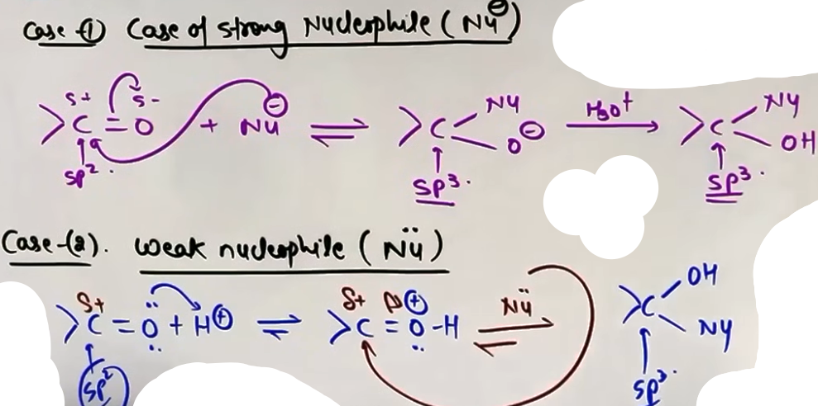
REACTIVITY FACTORS
Reactivity depends on two main factors:
1. Steric Factor: Larger alkyl groups around the carbonyl carbon hinder the approach of the nucleophile.
Order of reactivity: Formaldehyde > Other Aldehydes > Ketones.
2. Electronic Factor: Alkyl groups are electron-donating (+I effect). They reduce the partial positive charge (electrophilicity) on the carbonyl carbon.
Order of reactivity: Aldehydes (one R group) > Ketones (two R groups).
# Electron Withdrawing Groups (EWG) like -NO₂ increase reactivity, while Electron Donating Groups (EDG) like -OCH₃ decrease it.

SPECIFIC ADDITION REACTIONS

I) ADDITION OF HCN (CYANOHYDRIN FORMATION)
HCN adds to carbonyls to form cyanohydrins.
Since HCN is a weak acid, it provides very few CN⁻ ions, therefore the reaction is base-catalyzed (using OH⁻) to remove H⁺ from HCN and generate a high concentration of the CN⁻ nucleophile.
R-CHO + HCN → R-CH(OH)CN
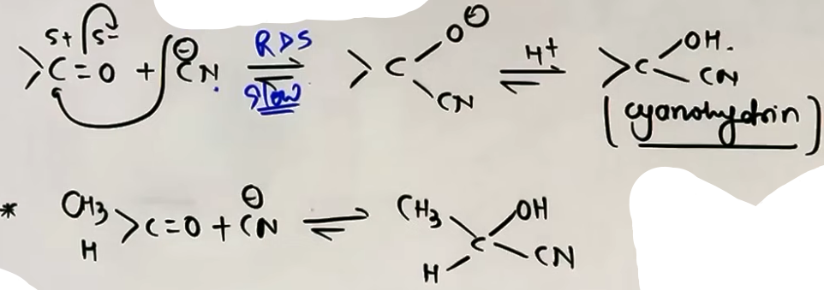
II) ADDITION OF NaHSO₃ (BISULFITE ADDUCT)
{NaHSO3 --> Sodium hydrogen sulphite or Sodium Bisulphite}
- Sodium hydrogen sulfite adds to aldehydes and ketones to form white crystalline bisulfite addition products.
- The position of the equilibrium lies largely to the right hand side for most aldehydes and to the left for most ketones due to steric reasons.
- These products are water-soluble and can be hydrolyzed back to the original carbonyl using dilute acid or base. This makes the reaction useful for the purification and separation of aldehydes/ketones.
- Steric Limitation: Bulky ketones like Diethyleketone, Acetophenone and Benzophenone do not give this reaction.
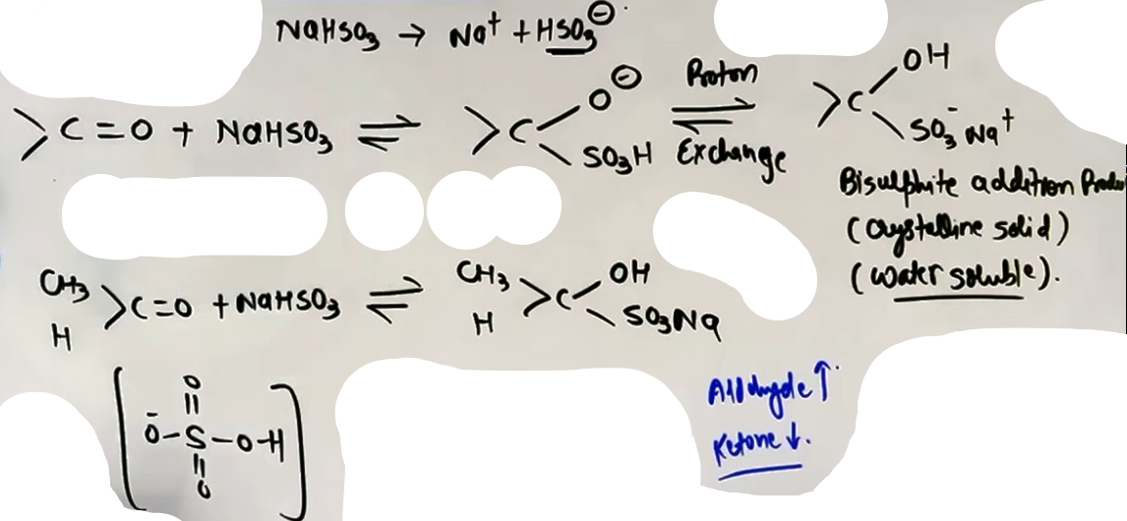
III) ADDITION OF GRIGNARD REAGENTS (R-MgX) {alcohol m ho gayi h}
Grignard reagents add to carbonyls followed by hydrolysis to form alcohols:
- Formaldehyde (HCHO) → 1° Alcohol
- Other Aldehydes (R-CHO) → 2° Alcohol
- Ketones (R-CO-R) → 3° Alcohol

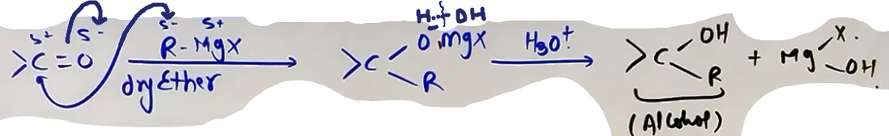

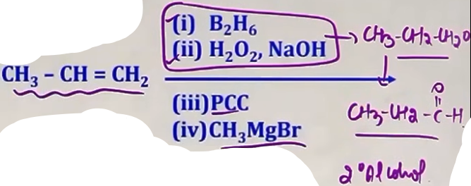

IV) ADDITION OF ALCOHOLS (ACETALS AND KETALS) {Imp}
- Aldehydes react with one equivalent of alcohol to form Hemiacetals (unstable) and with two equivalents to form Acetals (stable).
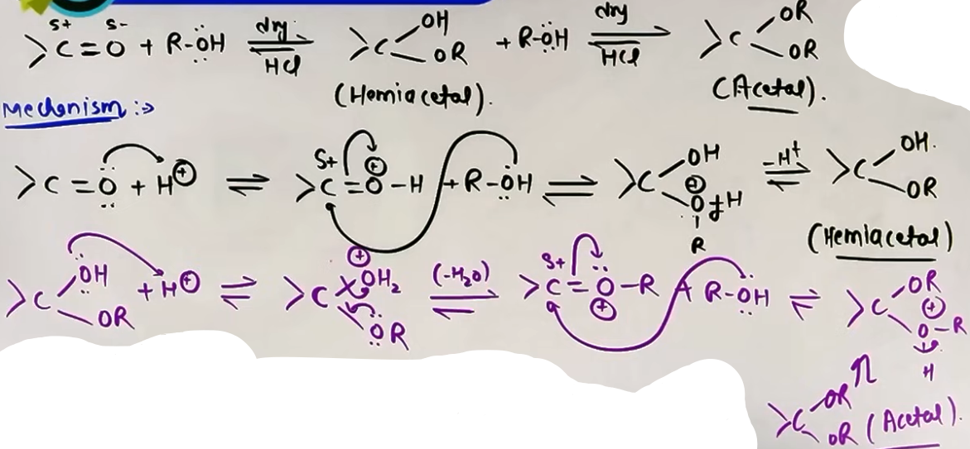
Mechanism
# jaisa uppar kaha tha weak nucleophile h toh acid catalyse karna para isliye yaha alcohol k sath dil. HCl lena pada
- Ketones do not easily form acetals with monohydric alcohols; they react with dihydric alcohols (like Ethylene Glycol) to form cyclic Ketals.
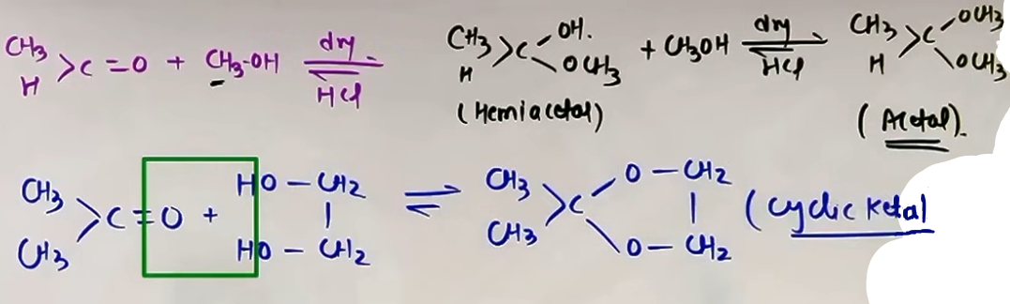
- Protection: Acetals/Ketals are stable in basic and neutral media but hydrolyze back to aldehyde/ketone in dilute mineral acids. This is used to protect carbonyl groups during synthesis.

V) ADDITION OF WATER (HYDRATION) {addition of alcohol ki tarah h same ditto}
Addition of water forms gem-diols (Hydrates). Generally, these are unstable and lose water to revert to the carbonyl.
Stability Exceptions (strong EWG at carbonyl carbon increases the stability of hydrates):
- Chloral Hydrate (CCl₃CH(OH)₂): Stable due to intramolecular hydrogen bonding between Cl and OH.
- Formaldehyde: Forms a stable hydrate in solution.
- Cyclopropanone: Stable hydrate due to the relief of angle strain when the carbon changes from 120° (sp²) to 109° (sp³). # dono m angle mil toh 60° raha h, pehle angle strain 120° – 60° = 60° tha aur dusre m 109° – 60° = 49°.

VI) AMMONIA AND ITS DERIVATIVES (H₂N-Z)
Carbonyls react with ammonia derivatives (Z-NH₂) under mild acidic conditions (pH 3.5 to 4.5). # weak nucleophile toh acid catalyzed
Mechanism: Nucleophilic addition followed by the elimination of water.
“R-C(=O)-R + H₂N-Z → R-C(=N-Z)-R + H₂O”
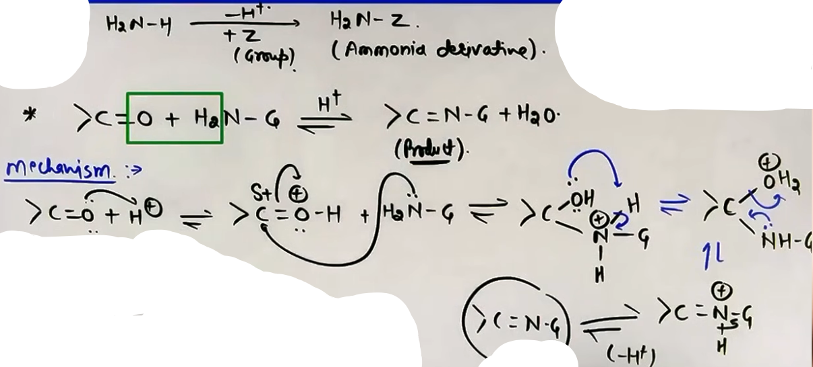
Products:
-| >C=O + NH₃(Ammonia) → C=NH(Imine)
-| >C=O + R-NH₂ → C=N-R(Schiff Base/Substituted Imine)
-| >C=O + NH₂OH(Hydroxylamine) → C=N-OH(Oxime)
-| >C=O + NH₂NH₂(Hydrazine) → C=N-NH₂(Hydrazone)
-| >C=O + NH₂NH-Ph (Phenylhydrazine) → C=N-NH-Ph(Phenylhydrazone)
-| >C=O + 2,4-DNP (2,4-Dinitrophenylhydrazine) → 2,4-DNP derivative (Yellow/Orange/Red ppt). This is the diagnostic test for carbonyl groups.
-| >C=O + NH₂-NH-C(O)-NH₂(Semi-carbazide) → C=N-NH-C(O)-NH₂ (Semi-carbazone).
(Note: Only that terminal NH₂ group reacts; the middle NH and the other NH₂ is involved in resonance).
Formaldehyde reacts with ammonia to form Hexamethylenetetramine (CH₂)₆N₄, known as Urotropine. It is used as a medicine for urinary tract infections.
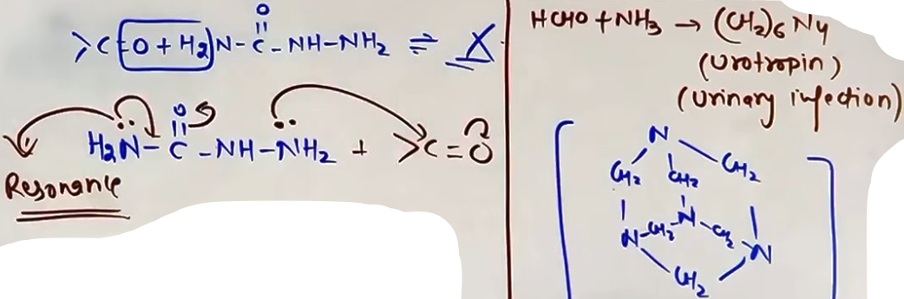

INTUITION AND CONCEPTUAL UNDERSTANDING

MENTAL MODEL FOR ATTACK
Visualize the carbonyl carbon as a "hungry" electrophilic center. Any group with a lone pair (nucleophile) will want to attack it. If the carbon is surrounded by "bulky bodyguards" (alkyl groups), the nucleophile cannot get close. If the alkyl groups are "feeding" the carbon electrons (+I effect), the carbon is less "hungry" and less reactive.

ACID CATALYSIS INTUITION
Think of the acid (H⁺) as a "coach" that motivates the carbonyl oxygen. By protonating the oxygen, it forces the oxygen to pull electrons away from the carbon even more strongly, making the carbon "desperately hungry" (electrophilic) so even weak nucleophiles can attack.

FORMULA SHEET
SPIN-ONLY MAGNETIC MOMENT
μ = √[n(n+2)] BM (Used in d-block, but referenced here for paramagnetic ions).

REACTION SCHEME
R-C(=O)-R + H₂N-Z → R-C(=N-Z)-R + H₂O

ALCOHOL REACTION STOICHIOMETRY
1 mol Aldehyde + 1 mol Alcohol → Hemiacetal
1 mol Aldehyde + 2 mol Alcohol → Acetal

PROBLEM-SOLVING FRAMEWORK
Question Type | Identification Clues | Approach / Strategy
Reactivity Comparison | Multiple C=O groups | Check Sterics (bulky groups) and Electronic (+I groups).
Purification Method | Mix of Aromatic/Aliph. | Use NaHSO₃; only aldehydes/methyl ketones react.
Protection Strategy | Basic reaction steps | Convert C=O to Acetal/Ketal to make it inert to base.
Hydrate Stability | CCl₃ group or strain | Look for H-bonding or relief of angle strain.
Site of NH₂ attack | Semi-carbazide reagent | Attack from the NH₂ group NOT involved in resonance.

JEE ADVANCED INSIGHTS

ACETAL STABILITY
Acetals are essentially ethers. They do not have an -OH group. This is why they are stable in basic conditions (which usually attack via OH⁻). However, in acid, the ether-like oxygen is protonated, leading to the regeneration of the carbonyl.

HEMIACETAL TRAP
Usually, hemiacetals are unstable. However, cyclic hemiacetals (like those in Carbohydrates) are very stable due to the "chelate effect" of being in a ring.

REACTION OF FORMALDEHYDE WITH NH₃
Unlike other aldehydes which form imines, Formaldehyde is so reactive it continues reacting to form the complex caged structure of Urotropine (CH₂)₆N₄.

HIGH-YIELD REVISION SHEET

MUST REMEMBER
- Carbonyl Carbon is Electrophilic; Oxygen is Nucleophilic.
- Reactivity: Aldehydes > Ketones.
- HCN addition needs Base Catalysis (generates CN⁻).
- NaHSO₃ adducts are white crystalline solids used for purification.
- 2,4-DNP (Brady's Reagent) gives Yellow/Orange/Red precipitate with C=O.
- Acetals/Ketals are protecting groups; they are base-stable.
- Formaldehyde + NH₃ → Urotropine.
- Chloral hydrate is a stable gem-diol due to H-bonding.

LAST-MINUTE REVISION POINTS
- pH for ammonia derivatives should be around 3.5 to 4.5.
- Semi-carbazide has two NH₂ groups; only the one far from the carbonyl reacts.
- Cyanohydrins (from HCN) are precursors to alpha-hydroxy acids (via hydrolysis).
- Bisulfite addition is reversible; adding dilute HCl recovers the aldehyde.
- Grignard + HCHO → Primary alcohol; others → Secondary; Ketone → Tertiary.

--------------------------------------------------------------------------------

REDUCTION REACTIONS

I) REDUCTION TO ALCOHOLS {alcohol m karle h}
Carbonyl groups can be reduced to alcohols using various hydride donors or catalytic hydrogenation.
NaBH₄ is a mild and selective reducing agent, it reduces aldehydes and ketones but generally leaves esters and carboxylic acids unreacted.
LiAlH₄ is a much stronger reducing agent that reduces most carbonyl-containing groups.
# It is an type of nucleophilic addition reaction.
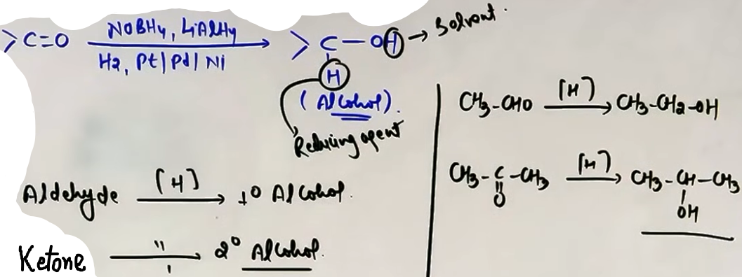
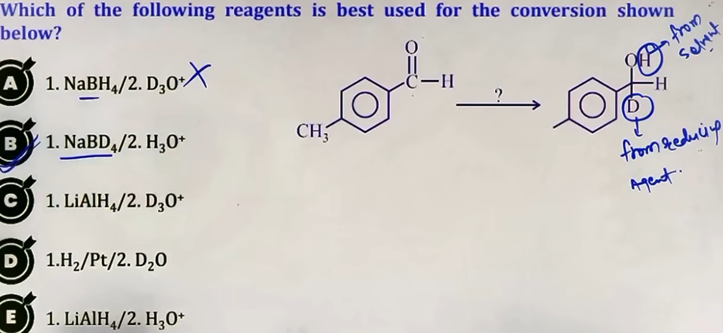
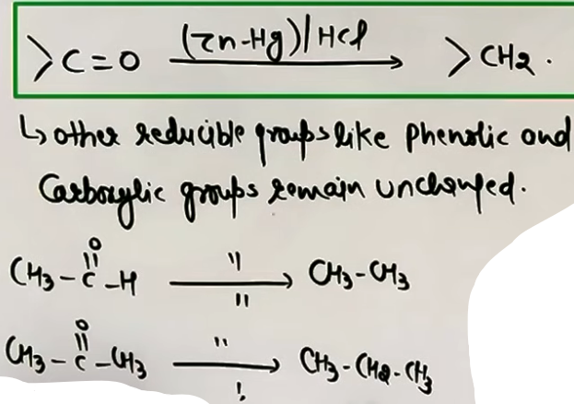

II) REDUCTION TO HYDROCARBONS (C=O TO CH₂)
There are three primary methods for the complete reduction of a carbonyl group to a methylene group (CH₂).
Clemmensen Reduction: Uses Zinc amalgam (Zn-Hg) and concentrated HCl.
It is used for compounds that are stable in strong acidic conditions.
# only reduces >C=O, lefts other reducable groups unaffected.

Wolff-Kishner Reduction: Uses Hydrazine (NH₂NH₂) followed by heating with KOH in ethylene glycol.
It is suitable for acid-sensitive compounds because the medium is basic.
# only reduces >C=O, lefts other reducable groups unaffected.
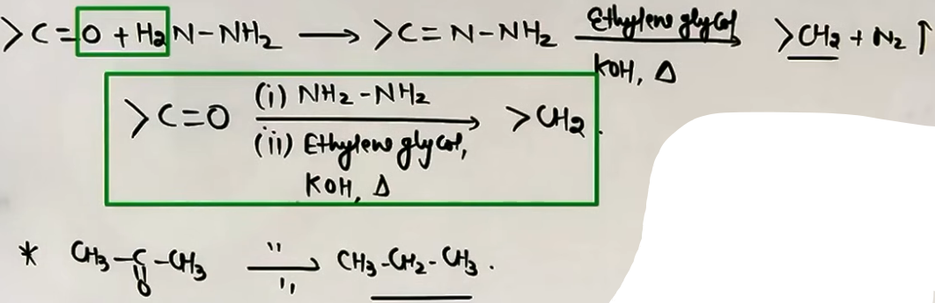
Red P and HI Reduction: This is a very strong and drastic reduction method.
It reduces aldehydes, ketones, and even carboxylic acids directly to alkanes when heated to about 420 K.

III) MPV (MEERWEIN-PONNDORF-VERLEY) REDUCTION
- This is a selective reduction of ketones into 2 degree alcohols.
- Reagents: Aluminum isopropoxide and isopropyl alcohol.
- It is specific for the C=O group and does not affect other reducible groups like nitro or halogen.
- This reaction is reversible; the reverse process is known as Oppenauer Oxidation.
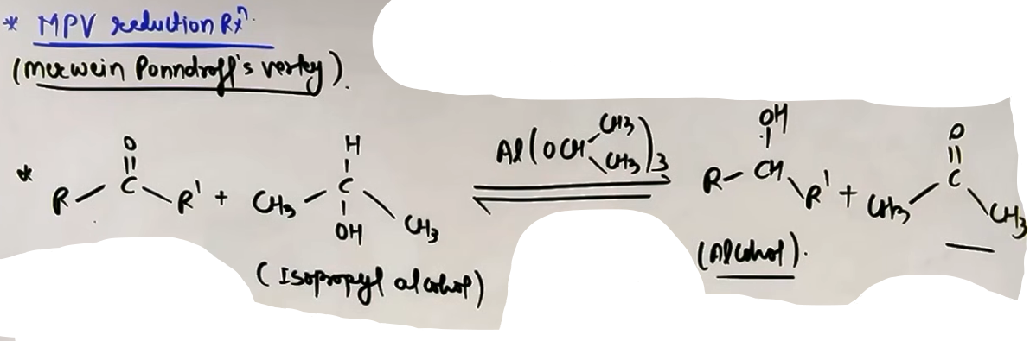
OXIDATION AND DIAGNOSTIC TESTS

OXIDATION - # jo pehle kar chuke h
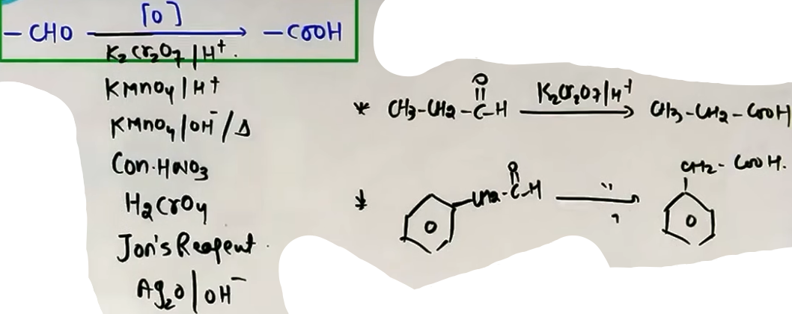
Oxidation by Tollen’s reagent OR Tollen's Test: Uses ammoniacal silver nitrate [Ag(NH₃)₂]⁺.
- Aldehydes reduce the Ag⁺ ion to metallic silver, forming a silver mirror on the test tube walls.
- All aldehydes (aliphatic and aromatic) give this test, but ketones do not, can be used to distinguish ketone and aldehyde.
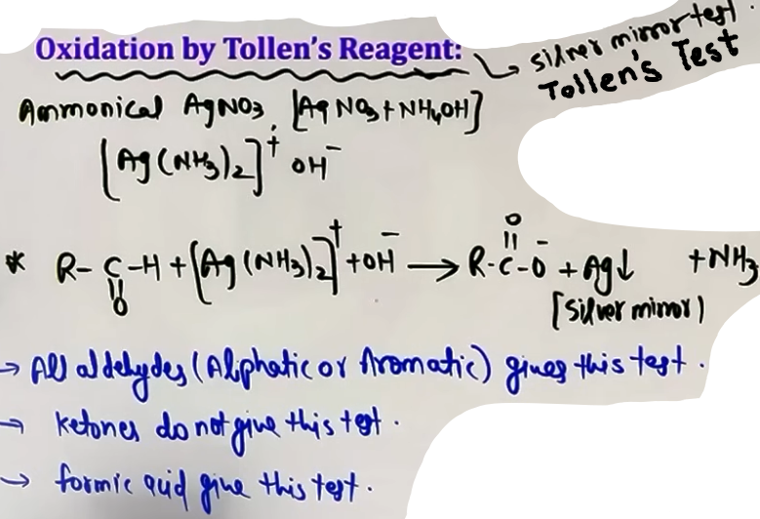
Oxidation by Fehling’s reagent OR Fehling's and Benedict's Tests: Use Cu²⁺ ions in alkaline medium stabilized by tartrate or citrate ions.
Aliphatic aldehydes reduce Cu²⁺ to a reddish-brown precipitate of Cu₂O.
Aromatic aldehydes (like Benzaldehyde) and ketones do not give this test.

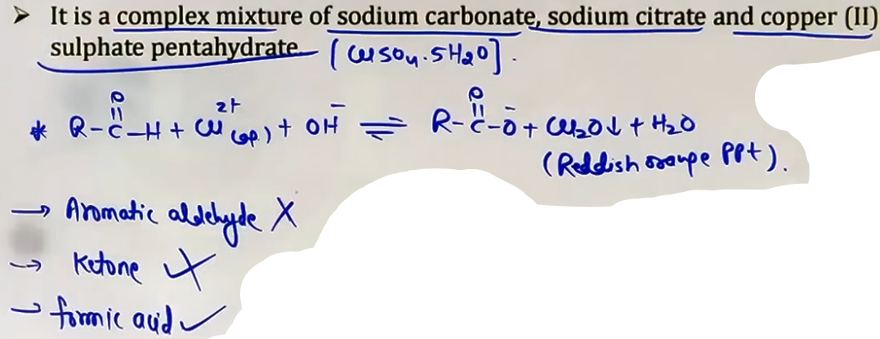

HALOFORM REACTION (IODOFORM TEST) {pehle kar liya h}
- This reaction is characteristic of methyl ketones (compounds with the CH₃CO- group).
- Reagents: Halogen (X₂) and NaOH (or NaOX).
- The methyl group is converted into a haloform (CHX₃).
If iodine (I₂) is used, a pale yellow precipitate of Iodoform (CHI₃) is formed.
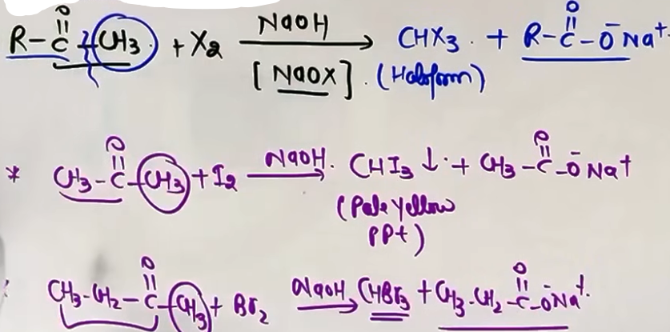
- Specific alcohols like Ethanol and 2-propanol also give this test because they are oxidized to methyl ketones in the reaction medium.
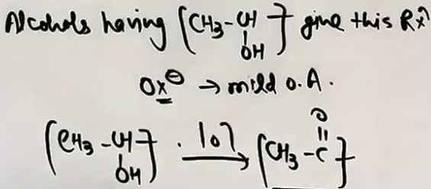
OXIDATION OF KETONES AND POPOFF'S RULE
- Ketones are difficult to oxidize and require strong agents like hot KMnO₄ or conc. HNO₃.
- The oxidation involves carbon-carbon bond cleavage.
- Popoff's Rule: During the oxidation of unsymmetrical ketones, the carbonyl group (C=O) remains with the smaller alkyl group.
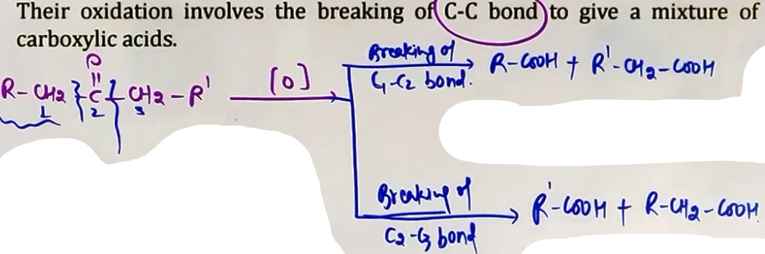
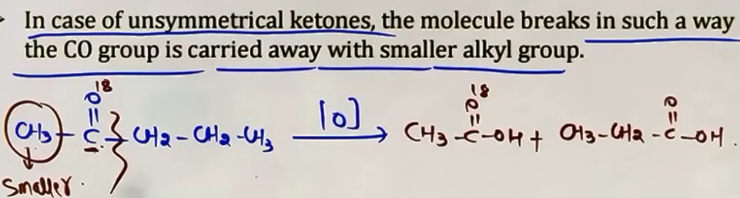

BAEYER-VILLIGER OXIDATION
- Ketones react with peracids (like MCPBA or Peracetic acid) to form esters.
- The reaction involves the insertion of an oxygen atom next to the carbonyl carbon.
- If the ketone is unsymmetrical, the oxygen inserts according to the migratory aptitude of the groups.
- Order: H > 3 degree Alkyl > 2 degree Alkyl > Phenyl > 1 degree Alkyl > Methyl.
If an EWG is on the phenyl ring, it migrates slower than an unsubstituted phenyl.
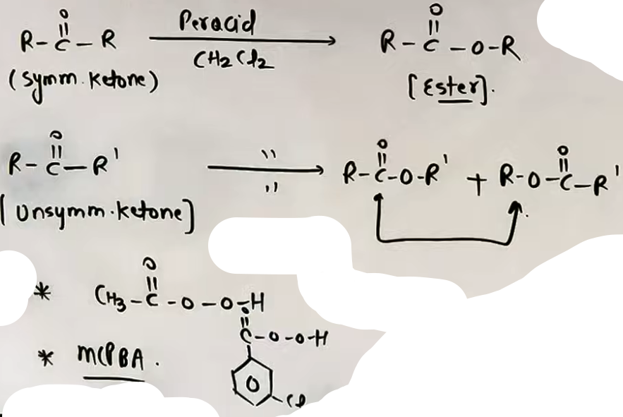
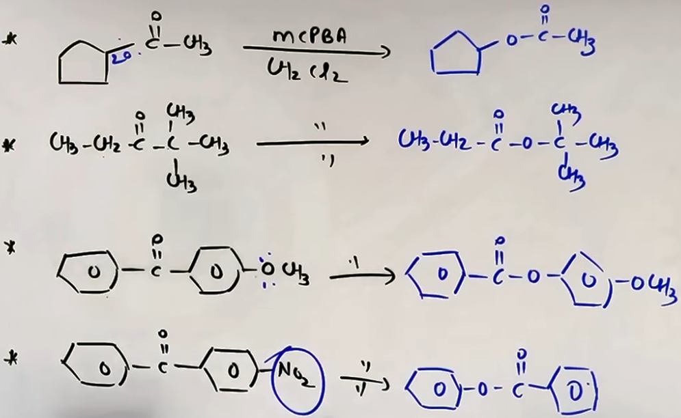
INTUITION AND CONCEPTUAL UNDERSTANDING
NUCLEOPHILIC VS ELECTROPHILIC BALANCE
- For diagnostic tests, remember that aldehydes are more reactive and easier to oxidize than ketones.
- Tollen's reagent is a mild oxidant; it can handle the reactive H of an aldehyde but cannot break the C-C bonds of a ketone.
- Fehling's is even milder, which is why it fails for aromatic aldehydes where the ring stabilizes the carbonyl center.
HALOFORM LOGIC
Think of the Haloform reaction as a "sacrifice" of the methyl group to create a carboxylic acid salt with the same number of carbons as the remaining chain.

FORMULA SHEET
REDUCTION TO ALCOHOLS
- Aldehyde + [H] -> 1 degree Alcohol
- Ketone + [H] -> 2 degree Alcohol
- Reagents: NaBH₄ (Mild/Selective) or LiAlH₄ (Strong)

HYDROCARBON REDUCTION
- Clemmensen: Zn(Hg) + conc. HCl
- Wolff-Kishner: 1. NH₂NH₂ 2. KOH / Ethylene Glycol
- Red P + HI: C=O -> CH₂ (Global reduction)

OXIDATION TESTS
- Tollen's: R-CHO + [Ag(NH₃)₂]⁺ -> R-COO⁻ + Ag (Silver Mirror)
- Fehling's: R-CHO + Cu²⁺ -> R-COO⁻ + Cu₂O (Red Ppt)

HALOFORM REACTION
- CH₃CO-R + 3X₂ + 4NaOH -> CHX₃ + R-COONa + 3NaX + 3H₂O

BAEYER-VILLIGER OXIDATION
- Ketone + R-COOOH -> Ester + R-COOH

PROBLEM-SOLVING FRAMEWORK
Question Type | Identification Clues | Strategy / Approach
Complete Reduction | Carbonyl to CH₂ | Check pH sensitivity: Acid (Clemmensen), Base (Wolff-Kishner).
Differentiate A/K | Test needed | Use Tollen's (Aromatic/Aliph) or Fehling's (Aliphatic only).
Methyl Ketone ID | Yellow Ppt with I₂/NaOH | Confirm CH₃CO- group via Iodoform.
Unsymmetrical Ketone | Peracid reagent (MCPBA) | Apply Baeyer-Villiger migratory aptitude for O-insertion.
EXAMPLES AND APPLICATIONS

EXAMPLE 1: REDUCTION SOURCE
Reaction: Cyclohexanone + NaBD₄ in H₂O.
Outcome: The D attaches to the carbon (from NaBD₄), and H attaches to the oxygen (from H₂O).

EXAMPLE 2: POPOFF'S RULE
Reaction: 2-Pentanone (CH₃-CO-CH₂CH₂CH₃) oxidized by hot KMnO₄.
Outcome: Carbonyl stays with methyl. Products: Acetic acid and Propanoic acid.

EXAMPLE 3: BENZALDEHYDE VS ACETALDEHYDE
Task: Differentiate using Fehling's.
Outcome: Acetaldehyde gives red Cu₂O ppt; Benzaldehyde (aromatic) does not.

HIGH-YIELD REVISION SHEET
MUST REMEMBER:
- NaBH₄ reduces C=O but NOT Esters/Acids.
- LiAlH₄ is the "Strong Bomb" for all carbonyls.
- Clemmensen = Acidic (Zn-Hg/HCl); Wolff-Kishner = Basic (NH₂NH₂/KOH).
- Tollen's = Silver Mirror (All RCHO + HCOOH).
- Fehling's = Red Ppt (Aliphatic RCHO only).
- Iodoform = Yellow Ppt (CH₃CO- group).
- Popoff's Rule = C=O stays with the smaller alkyl group during ketone cleavage.

LAST-MINUTE REVISION POINTS:
- Baeyer-Villiger migratory order: 3 degree > 2 degree > Ph > 1 degree > Methyl.
- Red P + HI is the "Global Reducer" to alkanes.
- Chloral hydrate is a rare stable gem-diol, but mostly C=O to C(OH)₂ is unstable.
- MPV reduction is specific for carbonyls and uses Aluminum isopropoxide.
- 2,4-DNP (Brady's Reagent) is the general test for ANY carbonyl (A/K), giving yellow/orange ppt.

--------------------------------------------------------------------------------

OTHER REACTIONS

ACIDITY OF ALPHA-HYDROGEN OF CARBONYL COMPOUNDS
The hydrogen atoms attached to the carbon atom adjacent to the carbonyl group (alpha-carbon) are acidic in nature.
Reason 1: The carbonyl group (C=O) is a strong electron-withdrawing group (-I and -M effect), which weakens the C-H bond on the alpha-carbon.
Reason 2: Deprotonation by a base forms a conjugate base called an enolate ion. This ion is stabilized by resonance, where the negative charge is delocalized onto the more electronegative oxygen atom.
Reactivity: More electron-withdrawing groups nearby increase acidity. More electron-donating groups (like alkyl groups) decrease acidity.

ALDOL CONDENSATION REACTION {V.V.Imp}
Condition 1: The aldehyde or ketone must have at least one alpha-hydrogen.
Condition 2: Reagent used is a dilute base (e.g., 10% NaOH, dilute KOH, Ba(OH)₂).

Self Aldol Condensation:
Two molecules of the same aldehyde or ketone react.
The base removes an alpha-H to form a nucleophilic enolate.
The enolate attacks the carbonyl carbon of the second molecule (Nucleophilic Addition).
Product: A beta-hydroxy aldehyde (Aldol) or beta-hydroxy ketone (Ketol).
Dehydration: Upon heating (Condensation), water is lost from the Aldol/Ketol to form an alpha,beta-unsaturated carbonyl compound.
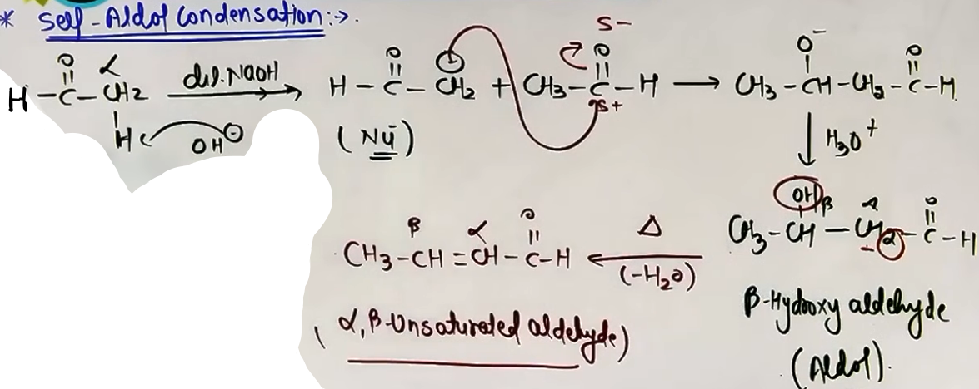agar heat nahi kiya toh aldol/ketol m reaction ruk jayegi
Cross Aldol Condensation:
Takes place between two different aldehydes or ketones.
If both have alpha-hydrogens, a mixture of four products is formed (two self-aldol and two cross-aldol products). #yaha major minor product ki baat nahi h
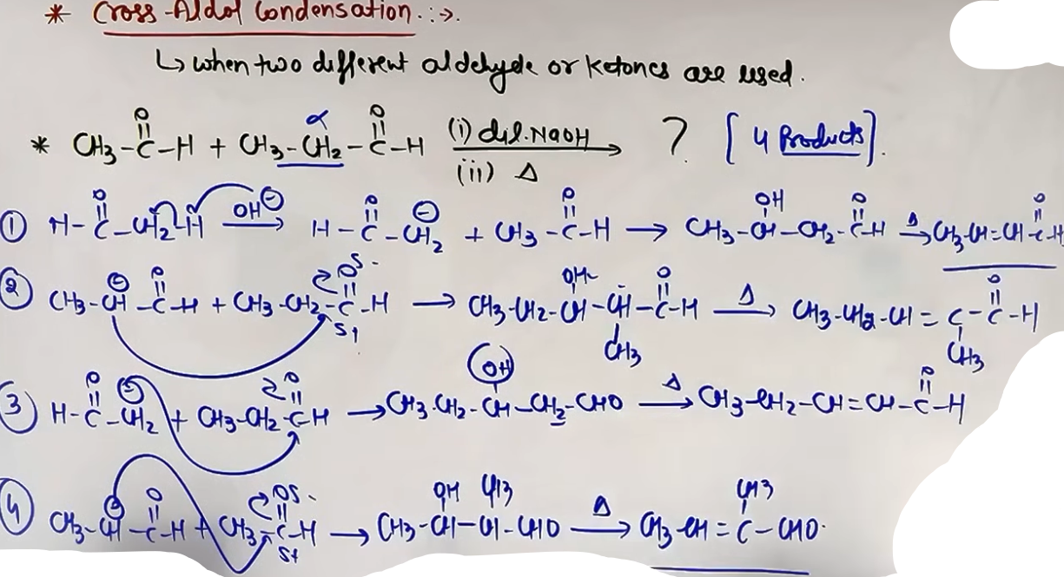
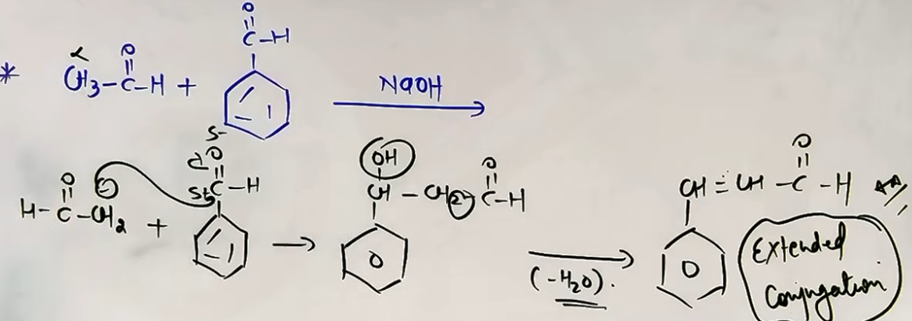If only one has alpha-hydrogens, it forms the enolate and attacks the one without alpha-hydrogens (e.g., Acetaldehyde + Benzaldehyde).

Intramolecular Aldol Condensation:
Occurs when two carbonyl groups are present in the same molecule (dialdehydes or diketones).
The enolate of one group attacks the other group to form a ring.
Stability: 5-membered and 6-membered rings are highly preferred over 3 or 7-membered rings due to lower angle strain.
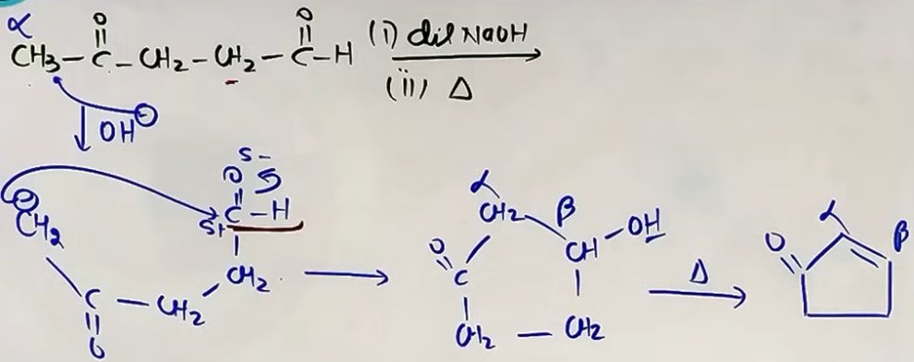
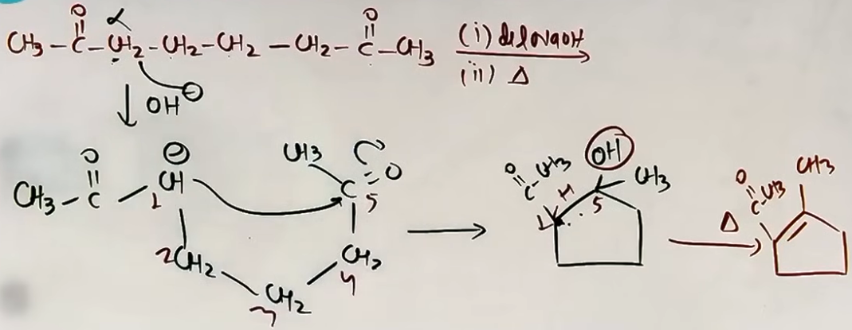
ALPHA-HALOGENATION
Aldehydes and ketones react with halogens (X₂ = Cl₂, Br₂, I₂) at the alpha-position.
Acid-Catalyzed Pathway:
Reagent: X₂ + Acid (e.g., CH₃COOH or H⁺).
Result: Generally leads to mono-halogenation (only one alpha-H is replaced), even it the halogen is in excess.
Reason: After one halogen is added, its electron-withdrawing effect makes the oxygen less nucleophilic, hindering the first step (protonation) required for a second substitution.
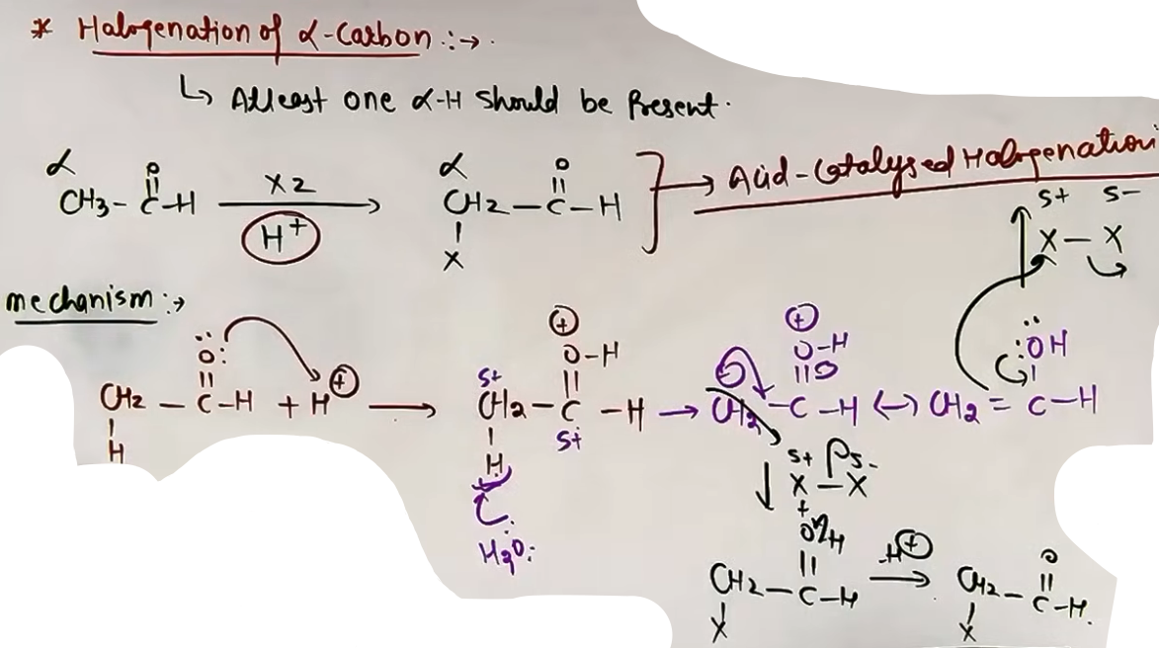
Base-Catalyzed Pathway:
Reagent: X₂ + Base (e.g., NaOH).
Result: Leads to poly-halogenation (all alpha-hydrogens are replaced) if the halogen is in excess.
Reason: The first halogen added increases the acidity of the remaining alpha-hydrogens due to its -I effect, making subsequent deprotonations by the base even faster.
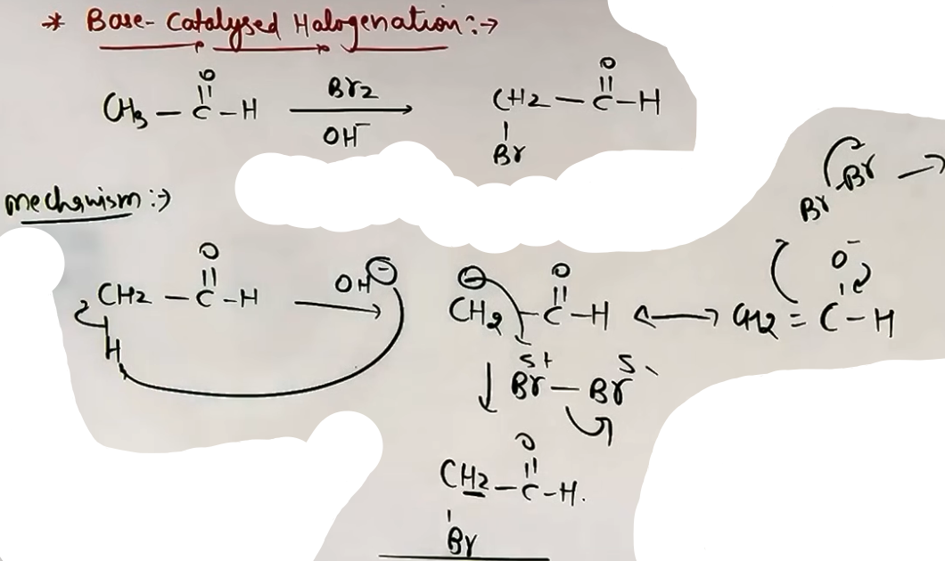
FORMULA SHEET
ALPHA-HYDROGEN ACIDITY
Acidic Strength proportional to Stability of Conjugate Base (Enolate).
Enolate Resonance: [CH₂⁻-C(=O)-H] <-> [CH₂=C(-O⁻)-H]

ALDOL REACTION SEQUENCE
Step 1: R-CH₂-CHO + OH⁻ -> [R-CH⁻-CHO] (Enolate)
Step 2: R-CH⁻-CHO + R-CH₂-CHO -> R-CH₂(CH(O⁻))-CH(R)-CHO
Step 3: Hydrolysis -> R-CH₂(CH(OH))-CH(R)-CHO (Beta-hydroxy carbonyl)
Step 4: Heat (-H₂O) -> R-CH₂-CH=C(R)-CHO (α,β-unsaturated product)

ALPHA-HALOGENATION
Acid Path (H⁺): R-CO-CH₃ + X₂ -> R-CO-CH₂X
Base Path (OH⁻): R-CO-CH₃ + Excess X₂ -> R-CO-CX₃

CONCEPT CONNECTIONS
Reaction | Connection to Other Topics
Enolate Formation | Linked to Keto-Enol Tautomerism in GOC.
Ring Formation | 5/6 membered preference links to Baeyer Strain Theory.
Acidity | Concepts of -I and -M effects from GOC.
Haloform Reaction | This is the extreme case of Base-Catalyzed Halogenation.

JEE ADVANCED INSIGHTS
KINETIC VS THERMODYNAMIC ENOLATES
In unsymmetrical ketones (e.g., 2-pentanone), two different enolates can form. Under cold, bulky base conditions, the less hindered alpha-H is removed (Kinetic). Under warmer, dilute base conditions, the more substituted (stable) enolate forms (Thermodynamic).

RESONANCE IN ALDOL PRODUCTS
The final condensation product is extra stable because the C=C double bond is in conjugation with the C=O double bond. This extended conjugation is the driving force for the dehydration step.

HIGH-YIELD REVISION SHEET
MUST REMEMBER
- Alpha-H is acidic due to resonance in the enolate ion.
- Aldol needs dilute base; Cannizzaro (no alpha-H) needs concentrated base.
- Aldol product: Beta-hydroxy carbonyl.
- Condensation product: Alpha,beta-unsaturated carbonyl.
- Intramolecular Aldol: 5 and 6 membered rings are king.
- Acid halogenation: Mono. Base halogenation: Poly.

LAST-MINUTE REVISION POINTS
- Formaldehyde, Benzaldehyde, and Chloral have NO alpha-H.
- In Cross-Aldol, if one molecule has no alpha-H, only 2 products are possible (1 self, 1 cross).
- Dehydration happens easily because the product is conjugated.
- Beta-keto acids decarboxylate easily, which is a common follow-up to alpha-halogenation/substitution.
- Base-catalyzed halogenation of methyl ketones leads to the Haloform reaction (CHI₃).

REACTION REAGENTS TABLE
+--------------------------+------------------+-----------------+
| Reaction | Reagent | Requirement |
+--------------------------+------------------+-----------------+
| Aldol | Dilute NaOH/KOH | Alpha-H present | |
| Condensation | Aldol + Heat | Loss of H₂O |
| Acid Halogenation | X₂ + CH₃COOH | Alpha-H present |
| Base Halogenation | X₂ + NaOH | Alpha-H present |
+--------------------------+------------------+-----------------+
--------------------------------------------------------------------------------
CANNIZZARO REACTION (SELF AND CROSS) {V.V.V.Imp}
The Cannizzaro reaction is a disproportionation (redox) reaction specific to aldehydes that do not possess any alpha-hydrogen atoms. In this reaction, one molecule of the aldehyde is reduced to an alcohol while the other is oxidized to the corresponding carboxylic acid salt.
Conditions for Cannizzaro:
- The aldehyde must have no alpha-hydrogens (e.g., Formaldehyde HCHO, Benzaldehyde C₆H₅CHO, or Trimethylacetaldehyde).
- A concentrated base must be present, such as 50% NaOH or 50% KOH.
Mechanism:
1. Nucleophilic attack of OH⁻ on the carbonyl carbon to form a tetrahedral intermediate.
2. Hydride shift: A hydride ion (H⁻) is transferred from the intermediate to a second aldehyde molecule. This is the Rate Determining Step (RDS).
3. Proton exchange: The resulting acid and alkoxide exchange a proton to form the final alcohol and carboxylate salt.
Self Cannizzaro: Occurs when two molecules of the same aldehyde react.
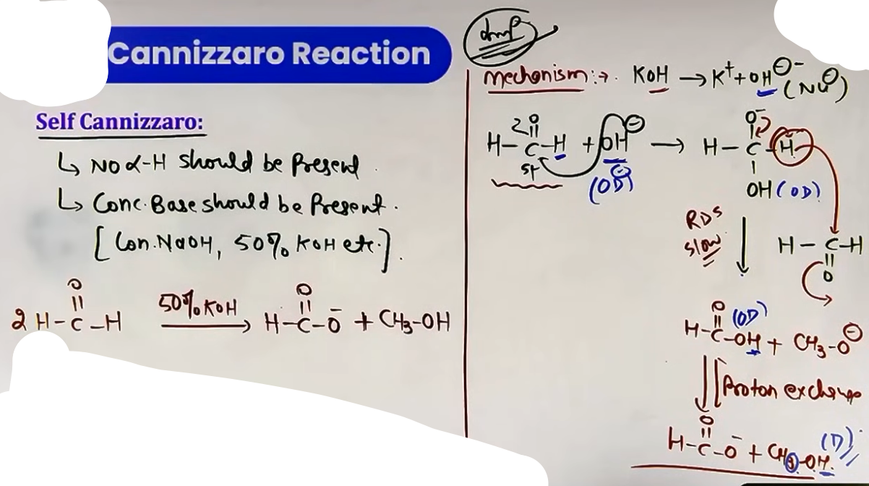
Cross Cannizzaro: Occurs between two different aldehydes that both lack alpha-hydrogens.
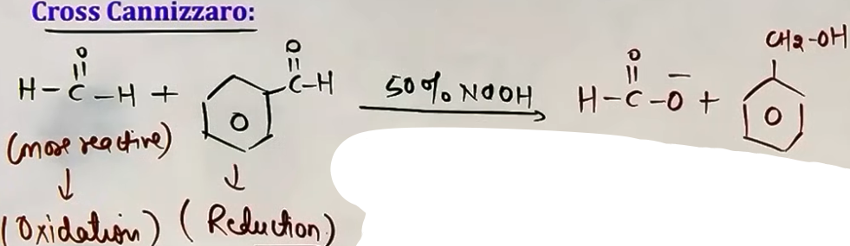
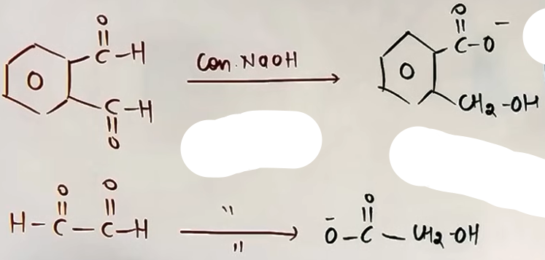
Intra-molecular Cannizzaro: Occurs when two carbonyl groups in the same molecule (lacking alpha-hydrogens) react internally.

BENZILIC ACID REARRANGEMENT
This reaction is a variation of the Cannizzaro mechanism occurring in 1,2-diketones like Benzil (C₆H₅-CO-CO-C₆H₅).
1. OH⁻ attacks one carbonyl carbon.
2. Instead of a hydride shift, an aryl group (e.g., phenyl) migrates to the adjacent carbonyl carbon.
3. Proton exchange results in the formation of a salt of an alpha-hydroxy carboxylic acid (Benzilic acid salt).
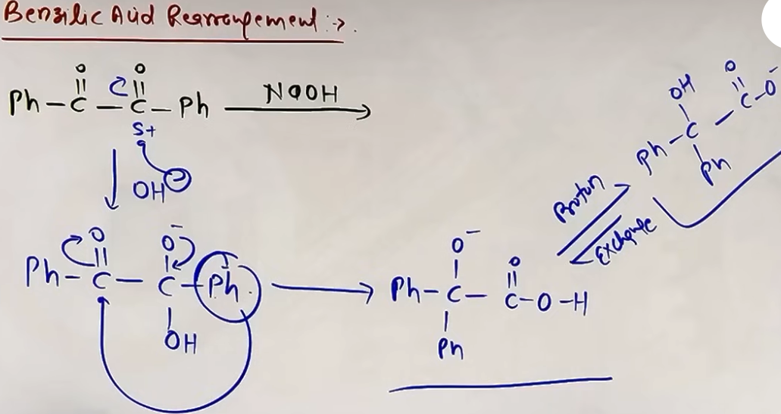
ELECTROPHILIC AROMATIC SUBSTITUTION (EAS) IN CARBONYLS
The carbonyl group (-CHO or -COR) attached to a benzene ring acts as a deactivating group and a meta-directing group for electrophilic aromatic substitution.
- Electronic nature: The group exerts -I (inductive) and -M (mesomeric) effects, withdrawing electron density from the ring.
- Reactivity: Carbonyl-substituted benzenes (like Benzaldehyde or Acetophenone) are less reactive than pure benzene toward EAS.
- Orientation: The electrophile (e.g., Br⁺, NO₂⁺, SO₃) primarily attacks the meta position.
PERKIN CONDENSATION {Not so Imp}
This reaction involves the condensation of an aromatic aldehyde with an aliphatic acid anhydride in the presence of the sodium salt of the corresponding acid.
- Requirement: The anhydride must have at least one alpha-hydrogen.
- Product: An alpha,beta-unsaturated aromatic acid, such as Cinnamic acid.
- Mechanism: The sodium salt acts as a base to generate a carbanion from the anhydride, which then attacks the aromatic aldehyde. Subsequent dehydration and hydrolysis yield the final acid.
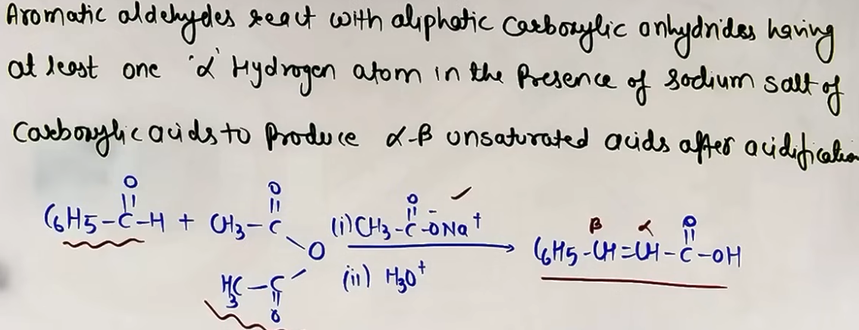
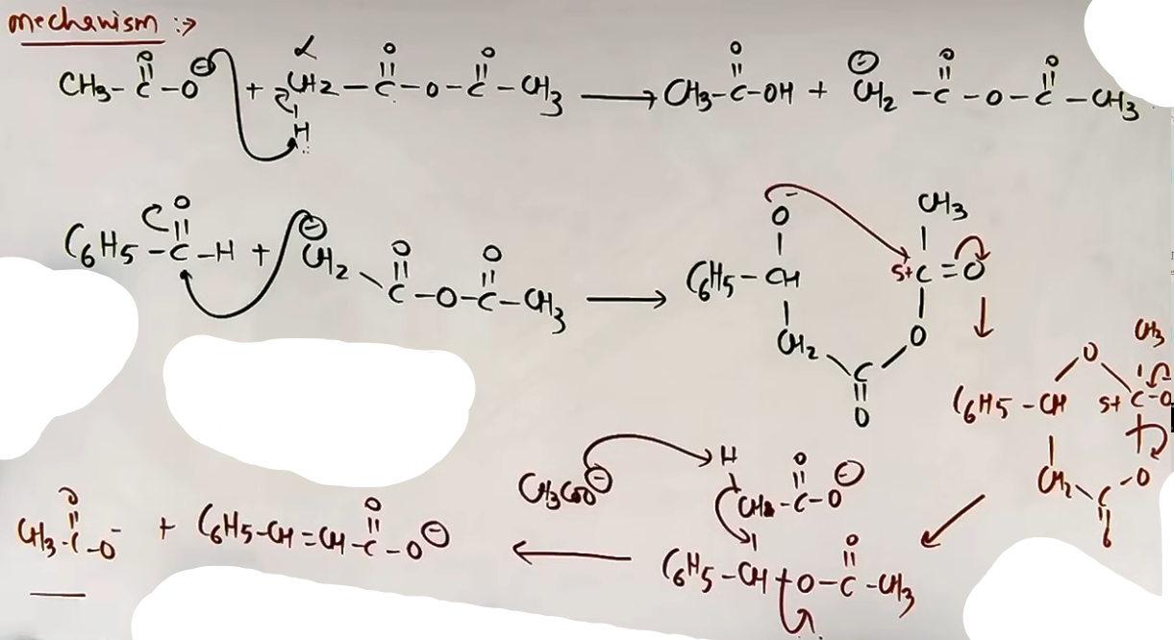

INTUITION AND CONCEPTUAL UNDERSTANDING
CANNIZZARO REACTIVITY
To predict the outcome of a Cross Cannizzaro reaction, identify the more reactive aldehyde. The nucleophile (OH⁻) will attack the more electrophilic (more reactive) carbon first. Consequently, the more reactive aldehyde is always oxidized to the acid salt, and the less reactive one is reduced to the alcohol. For example, in a reaction between Benzaldehyde and Formaldehyde, Formaldehyde is more reactive and will be oxidized to Sodium Formate.

FORMULA SHEET
CANNIZZARO SUMMARY
2 HCHO + 50% NaOH -> HCOONa + CH₃OH
H-source in alcohol: The H on Carbon comes from the aldehyde; the H on Oxygen comes from the solvent/base.

BENZILIC ACID REARRANGEMENT
Ph-CO-CO-Ph + NaOH -> (Ph)₂C(OH)COONa

PERKIN CONDENSATION
Ar-CHO + (CH₃CO)₂O --(CH₃COONa)--> Ar-CH=CH-COOH

EAS POSITIONING
Ar-CHO + Br₂ (FeBr₃) -> Meta-bromo benzaldehyde
Ar-CHO + Conc. HNO₃/H₂SO₄ -> Meta-nitro benzaldehyde
PROBLEM-SOLVING FRAMEWORK
Question Type | Identification Clues | Approach / Strategy
Cannizzaro Product | No alpha-H + Conc. Base | Oxidize one to salt, reduce other to alcohol.
Cross Cannizzaro | Two diff aldehydes | More reactive = Acid salt; Less reactive = Alcohol.
Intramolecular Cann. | Dialdehyde (no alpha-H) | One CHO to COO⁻, other to CH₂OH in same molecule.
EAS Regioselectivity | Carbonyl ring + Electrophile | Place incoming group at the meta position.
Perkin Condensation | Ar-CHO + Anhydride + Salt | Remove H₂O from Alpha-C of anhydride and Carbonyl O.

JEE ADVANCED INSIGHTS
ISOTOPIC LABELLING
In the Cannizzaro reaction, the H attached to the oxygen in the resulting alcohol comes from the solvent (D₂O/H₂O), while the H attached to the carbon comes directly from the other aldehyde molecule.

PERKIN REACTION RATE
Adding electron-withdrawing groups to the aromatic ring increases the rate of the Perkin condensation because it makes the carbonyl carbon more electrophilic for the carbanion attack.

COMMON MISTAKES AND TRAPS
Mistake | Why Students Make It | Correct Approach / Thinking
Confusing base conc. | Mixing Aldol and Cann. | Dilute Base = Aldol; Conc. Base = Cannizzaro.
Oxidizing wrong aldehyde | In Cross Cannizzaro | Always oxidize the most reactive one (usually HCHO).
ortho/para EAS | Treating CHO as EDG | CHO is EWG; it MUST be meta-directing.
Skipping alpha-H requirement | In Perkin Reaction | Anhydride MUST have alpha-H for carbanion formation.

HIGH-YIELD REVISION SHEET

MUST REMEMBER:
- Cannizzaro: No alpha-H + Conc. NaOH -> Salt + Alcohol.
- Cross Cannizzaro Rule: More reactive aldehyde -> Salt.
- Perkin Reagents: Ar-CHO + Anhydride + Sodium Salt -> Unsaturated Acid.
- EAS in Carbonyls: Meta-directing and deactivating.
- Urotropine: Reaction of formaldehyde with NH₃ yields (CH₂)₆N₄.

LAST-MINUTE REVISION POINTS:
- Benzilic acid rearrangement involves aryl migration.
- Hydride shift is the RDS in Cannizzaro.
- Beta-keto acids decarboxylate easily upon heating.
- Sodium bicarbonate test: Carboxylic acids give CO₂ gas.
- 2,4-DNP test is positive for all aldehydes and ketones.

--------------------------------------------------------------------------------

CARBOXYLIC ACIDS

The carboxylic carbon is sp² hybridized with a planar geometry and bond angles of approximately 120°.
The group consists of a carbonyl (C=O) and a hydroxyl (-OH) group.
Resonance stabilization: The lone pairs on the hydroxyl oxygen are delocalized into the carbonyl group.
Resonance Structures:
R-C(=O)-OH <-> R-C(-O⁻)=O⁺H

REACTIVITY COMPARISON
The carbonyl carbon in carboxylic acids is less electrophilic than in aldehydes and ketones.
In aldehydes/ketones, the carbon has a strong partial positive charge (δ⁺).
In acids, resonance from the hydroxyl oxygen provides electron density to the carbonyl carbon, partially neutralizing the δ⁺ charge.
(Note) Consequently, carboxylic acids do not typically undergo the simple nucleophilic addition reactions characteristic of aldehydes and ketones.

METHOD OF PREPARATION

FROM OXIDATION OF ALCOHOLS
R-CH₂-OH -->{Strong oxidising agent} R-C(=O)-OH
Oxidising agents same as in ~alde30

FROM OXIDATION OF ALDEHYDES AND KETONES
isse chapter m pehle padh liye h

OXIDATION OF ALKYLBENZENES
- Aromatic carboxylic acids are prepared by oxidizing alkylbenzenes with strong agents like alkaline/acidic KMnO₄, Chromic acid etc. followed by acidification.
- (Important) Benzylic Hydrogen Requirement: The alkyl group must have at least one hydrogen atom on the carbon directly attached to the benzene ring (benzylic carbon), therefore tertiary butyl benzene does not undergo this oxidation because it lacks a benzylic hydrogen.
- The entire alkyl chain, regardless of its length, is oxidized down to a single -COOH group.
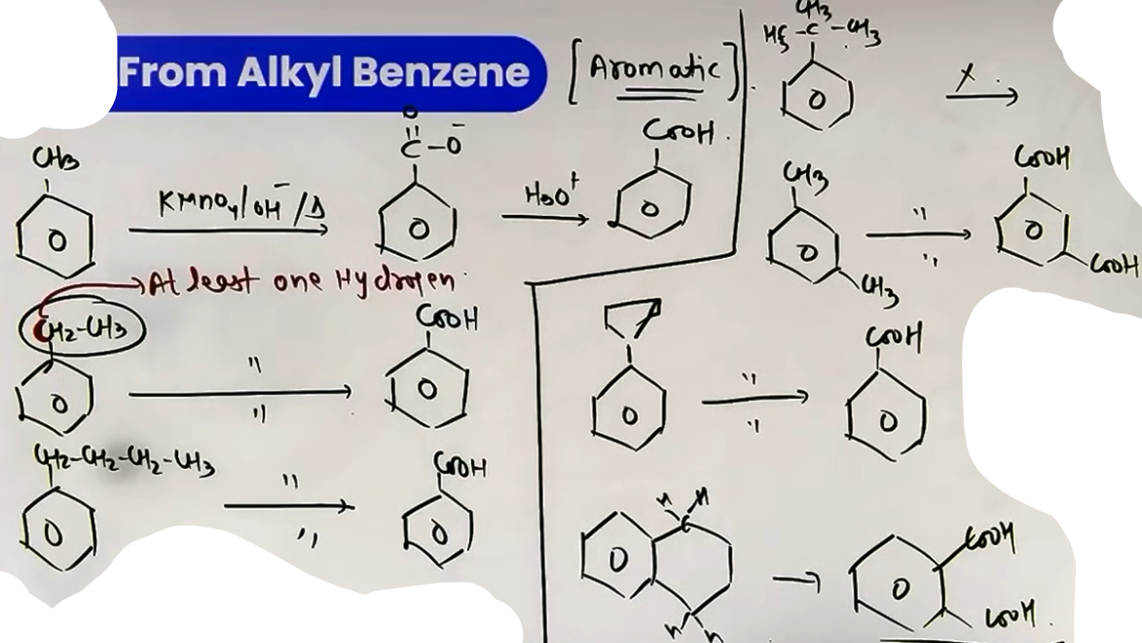
FROM HYDROLYSIS OF NITRILES AND AMIDES {Imp}
Nitriles (Cyanides) undergo hydrolysis in acidic (H⁺) or basic (OH⁻) media.
- Partial Hydrolysis: R-CN + H₂O -> R-CONH₂ (Amide).
- Complete Hydrolysis: R-CONH₂ + H₂O -> R-COOH + NH₃.
(Note) If the query does not specify, always assume complete hydrolysis to the acid.
GRIGNARD REAGENTS WITH CO₂
- Grignard reagents (R-MgX) react with solid CO₂ (dry ice) in dry ether to form a carboxylate salt, which yields a carboxylic acid upon hydrolysis.
R-MgX + O=C=O -> R-COOMgX -> R-COOH.
- (Strategy) This method is used to increase the carbon chain length by one carbon.
- The R group comes from the Grignard reagent, and the -COOH carbon comes from CO₂ and hydrogen from solvent.
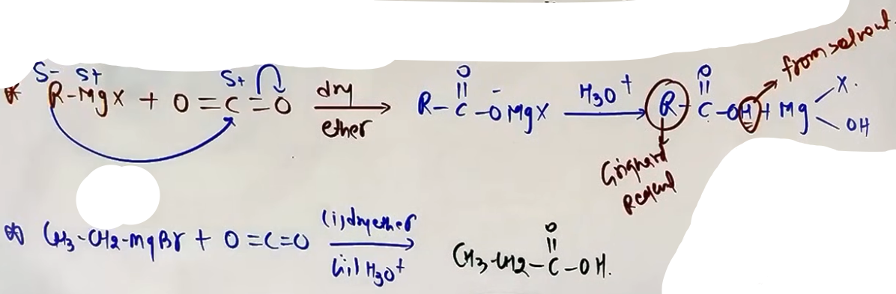
FROM ACYL HALIDES AND ANHYDRIDES

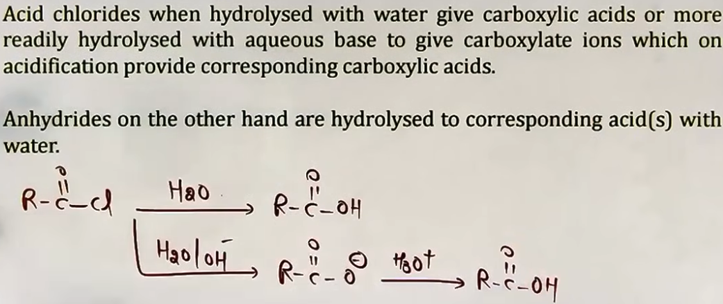
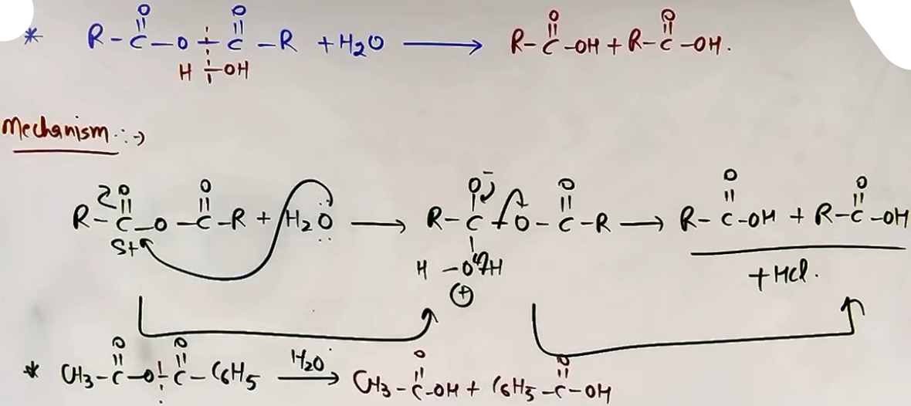
FROM ESTERS

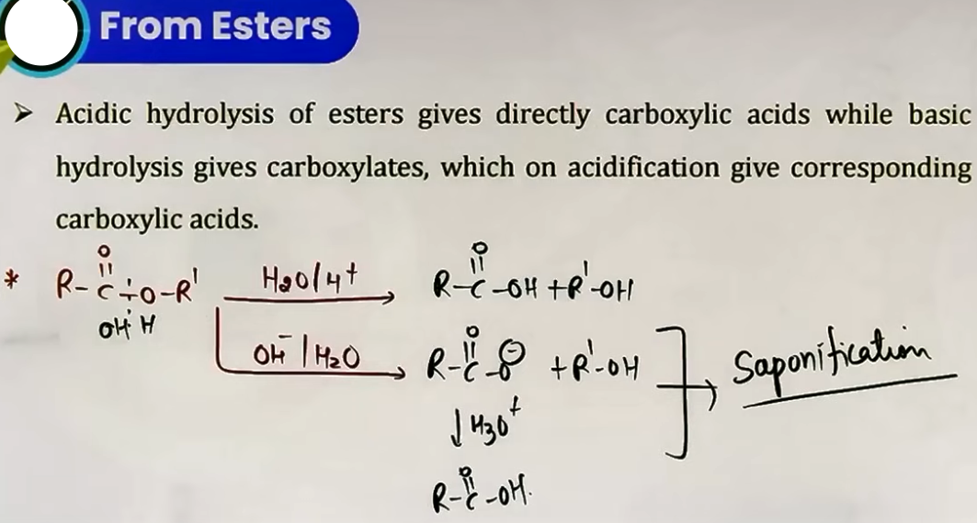
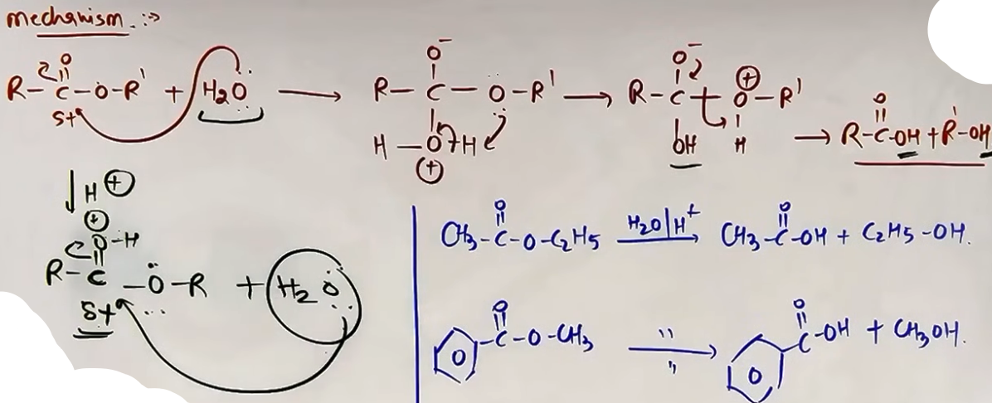

FROM TRIHALOGEN DERIVATIVES OF HYDROCARBONS
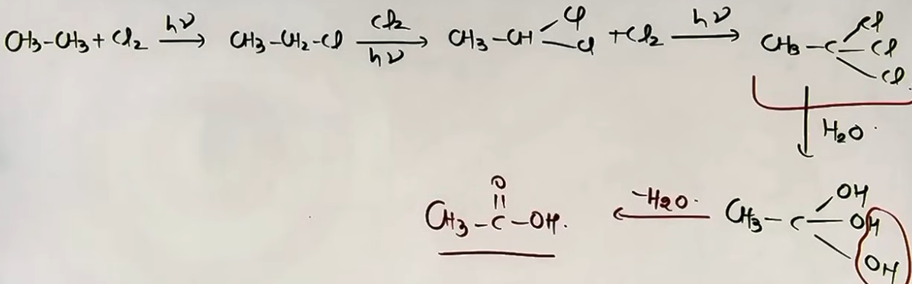

FROM OXIDATION OF ALKENES
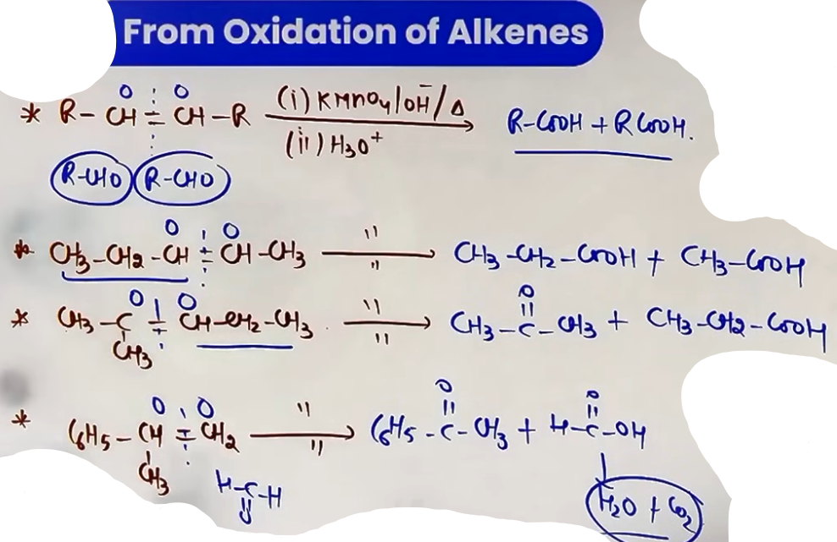
# ketone ka furthur oxidation nahi hota
# H-COOH unstable rehta h toh H₂O aur CO₂ m tut gaya

FROM CARBOXYLATION OF ALKENES [KOCH REACTION]
Alkenes react with CO and H₂O in the presence of acid catalysts (H₃PO₄) at high temperature and pressure.
CH₂=CH₂ + CO + H₂O -> CH₃-CH₂-COOH.
(Advanced) The reaction involves a carbocation intermediate; the -COOH group attaches to the most substituted carbon to form the more stable product.

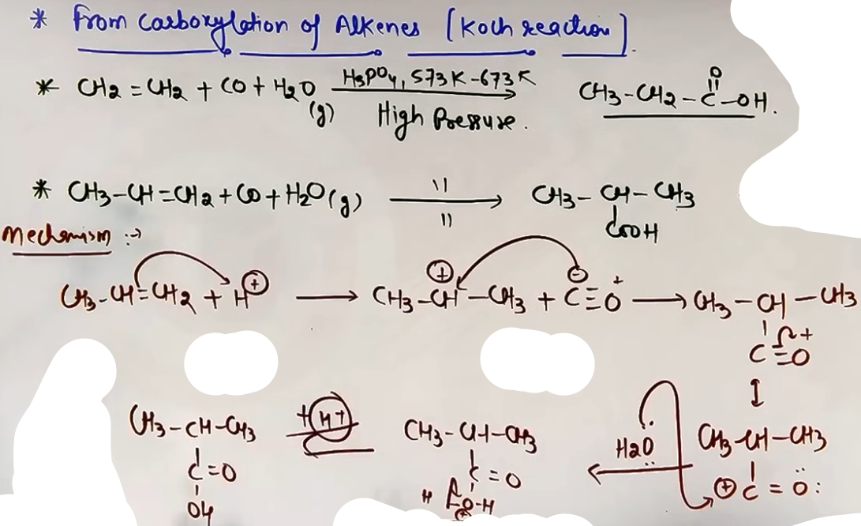
PHYSICAL PROPERTIES
BOILING POINT AND DIMERIZATION
- Carboxylic acids have higher boiling points than aldehydes, ketones, and even alcohols of comparable molecular mass.
- This is due to extensive association due to intermolecular hydrogen bonding.
- Dimerization: In the vapor phase or in aprotic solvents (like Benzene), carboxylic acids exist as cyclic dimers held by two hydrogen bonds.
- Calculated mass of Acetic Acid = 60; Observed mass = 120 (due to dimer).

SOLUBILITY
- Lower aliphatic carboxylic acids (up to 4 carbons) are miscible in water due to H-bonding with water.
- Solubility ∝ 1 / Size of hydrophobic alkyl group.
- Benzoic acid: Insoluble in cold water but soluble in hot water.
CHEMICAL REACTIONS

REACTION INVOLVING CLEAVAGE OF O-H BOND

ACIDITY OF CARBOXYLIC ACIDS
Carboxylic acids are more acidic than alcohols and phenols.
Acidic Strength ∝ Stability of Carboxylate Ion (Conjugate Base).
The carboxylate ion (R-COO⁻) is highly stable because the negative charge is delocalized over two equivalent electronegative oxygen atoms.

FACTORS AFFECTING ACIDITY
1. Inductive Effect:
- Electron Withdrawing Groups (EWG): Increase acidity by stabilizing the negative charge (-I effect).
- Electron Donating Groups (EDG): Decrease acidity by destabilizing the charge (+I effect).
- Order: F-CH₂COOH > Cl-CH₂COOH > Br-CH₂COOH > I-CH₂COOH.
2. Ortho Effect:
- In Benzoic acids, ortho-substituted derivatives are almost always more acidic than benzoic acid itself, regardless of whether the group is an EWG or EDG.
- This is due to steric inhibition of resonance (SIR), which forces the -COOH group out of the plane of the ring, preventing the ring from destabilizing the carboxylate ion.

REACTION INVOLVING CLEAVAGE OF C-OH BOND

REACTION WITH PCl₅, PCl₃, AND SOCl₂ {same as in alcohol}
The -OH group of carboxylic acids is replaced by -Cl to form acid chlorides.
R-COOH + PCl₅ -> R-COCl + POCl₃ + HCl.
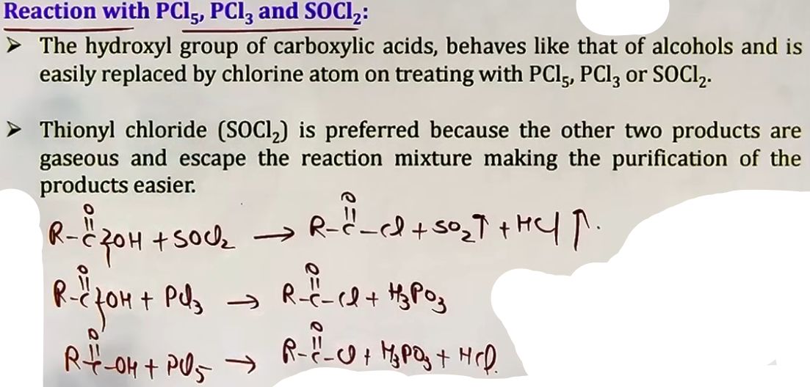Figure 3: R-COOH + SOCl₂ -> R-COCl + SO₂ + HCl.
REACTION WITH AMMONIA TO FORM AMIDES {Imp}
Acids react with ammonia to form ammonium salts which, upon heating, lose water to form amides.
R-COOH + NH₃ ⇌ R-COO⁻(NH₄)⁺ (heat) -> R-CONH₂ + H₂O.
Special Case (Phthalic Acid):
Forms Phthalimide via ammonium phthalate and thalimide under strong heating.
Thalimide + Strong Heat -> Phthalimide (cyclic amide) + NH₃.
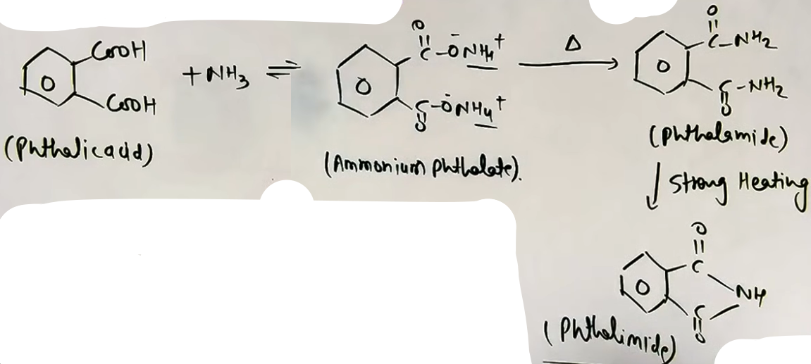

FORMATION OF ANHYDRIDES

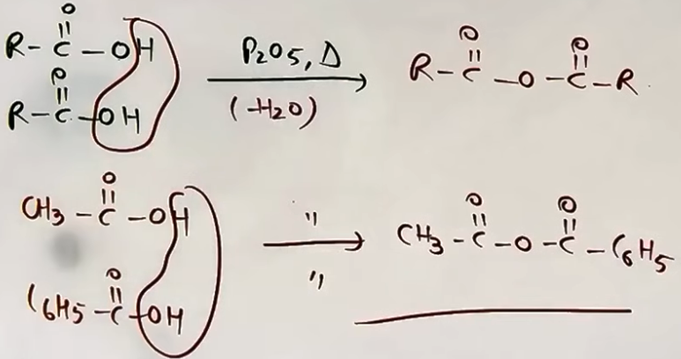
ESTERIFICATION REACTION {alcohol m karli h}

REACTION AND MECHANISM
Carboxylic acids react with alcohols in the presence of a mineral acid catalyst (conc. H₂SO₄ or HCl gas) to form esters.
R-COOH + R'-OH ⇌ R-COOR' + H₂O.
Mechanism: Nucleophilic Acyl Substitution.
(Warning) The -OH group is removed from the carboxylic acid, while only the -H is removed from the alcohol.
The reaction is reversible; water must be removed to shift the equilibrium to the product side.

STERIC EFFECTS
Rate of Esterification ∝ 1 / Steric hindrance of Acid or Alcohol.
Reactivity of Alcohols: CH₃OH > 1° > 2° > 3°.
Reactivity of Acids: HCOOH > CH₃COOH > RCH₂COOH > R₂CHCOOH > R₃CCOOH.
SUBSTITUTION REACTIONS IN THE HYDROCARBON PART

HALOGENATION [HELL-VOLHARD-ZELINSKY (HVZ) REACTION]
Carboxylic acids having at least one alpha-hydrogen react with Chlorine or Bromine in the presence of small amounts of Red Phosphorus to give alpha-halo carboxylic acids.
R-CH₂-COOH (1. X₂/Red P; 2. H₂O) -> R-CH(X)-COOH.
(Note) Red P reacts with X₂ to form PX₃ in-situ, which initiates the reaction.
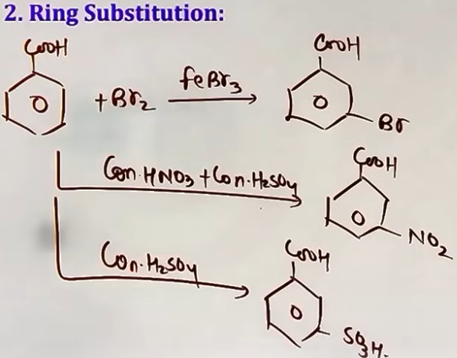

RING SUBSTITUTION
# -COOH is an deactivating/meta directing group

REACTIONS INVOLVING -COOH GROUP

REDUCTION {alcohol preparation m kar li}
- Carboxylic acids are reduced to primary alcohols by lithium aluminium hydride or better with diborane.
- Diborane does not easily reduce functional groups such as ester, nitro, halo, etc.
- Sodium borohydride does not reduce the carboxyl group.
R-COOH -->{i. LiAlH₄/dry ether, ii. H₂O} R-CH₂-OH
R-COOH -->{i. B₂H₆/THF} R-CH₂-OH
R-COOH -->{i. Red P + HI, Δ} R-CH₃
# Red P itna tagra reducing agent h

SODA LIME DECARBOXYLATION
Sodium salts of carboxylic acids are heated with soda lime (NaOH and CaO in 3:1 ratio) to give alkanes.
R-COONa + NaOH (CaO, heat) -> R-H + Na₂CO₃.
(Strategy) The product alkane has one carbon less than the starting salt.

DECARBOXYLATION BY HEATING OF BETA-KETO ACIDS
Carboxylic acids with a keto group at the beta-position (Beta-keto acids) undergo decarboxylation simply by heating.
R-CO-CH₂-COOH (heat) -> R-CO-CH₃ + CO₂.
Reason: Formation of a stable six-membered cyclic transition state.

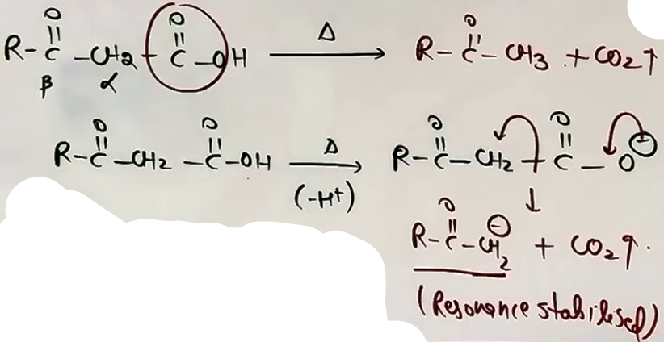
DECARBOXYLATION BY HEATING OF BETA-DECARBOXYLIC ACIDS (GEM-DICARBOXYLIC ACIDS)

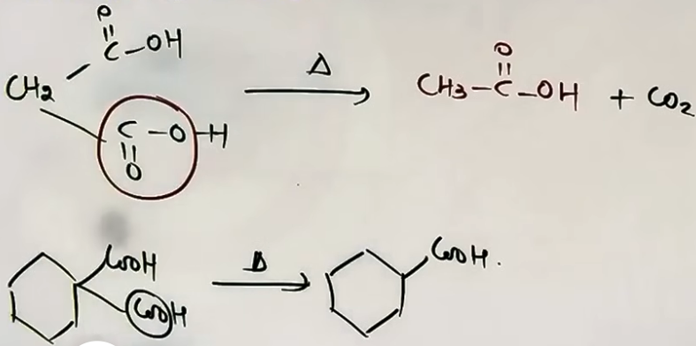
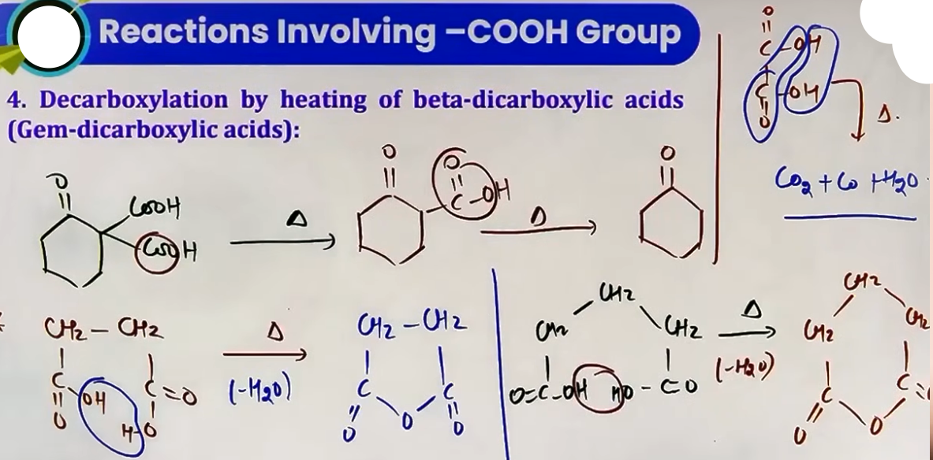# agar gem nahi toh H₂O nikalna hoga
# vo uppar kone wali koi inorganic ki reaction h

KOLBE'S ELECTROLYSIS
An aqueous solution of the sodium or potassium salt of a carboxylic acid on electrolysis with water gives alkanes containing an even number of carbon atoms.
2R-COONa + 2H₂O (electrolysis) -> R-R + 2CO₂ + H₂ + 2NaOH.
At Anode: R-R (alkane) and CO₂ gas.
At Cathode: H₂ gas.
(Note) Methane (CH₄) cannot be prepared by this method.

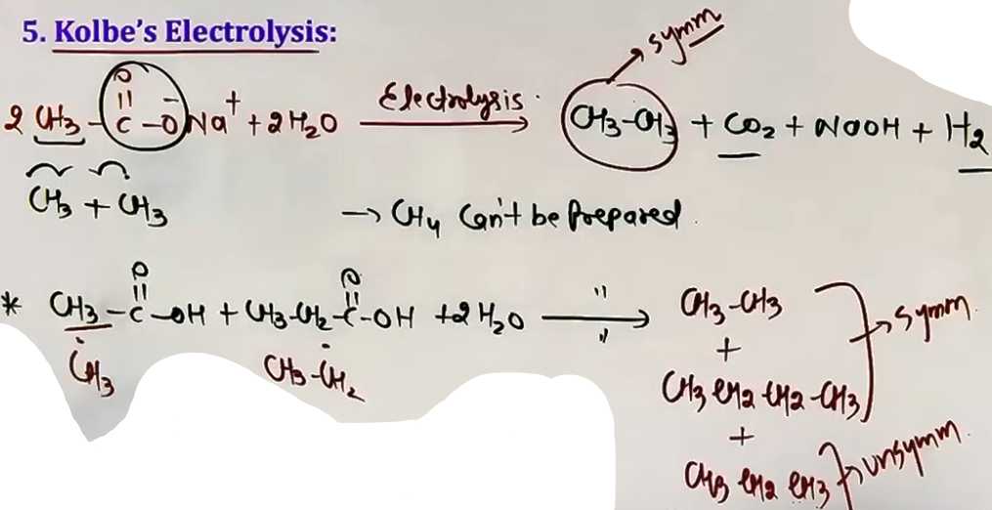

HEATING OF CALCIUM SALTS OF CARBOXYLIC ACIDS
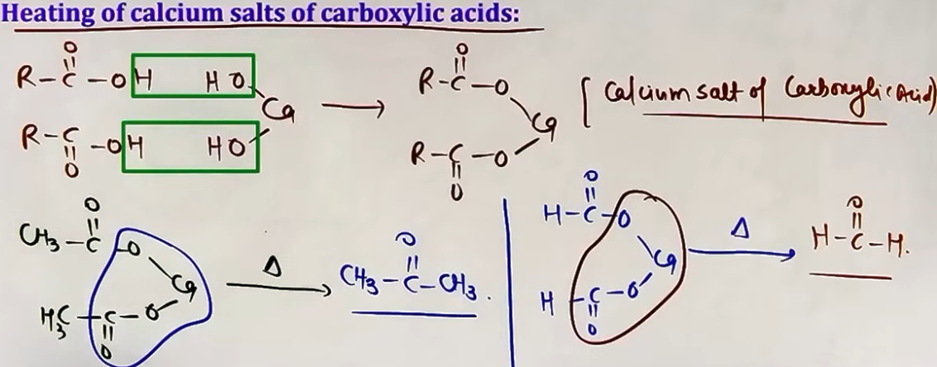# CaCO₃ bhi banega

REACTIVITY OF ACID DERIVATIVES
The reactivity of carboxylic acid derivatives towards nucleophilic acyl substitution follows the order of leaving group ability.
Reactivity Order:
Acid Chloride > Acid Anhydride > Ester > Amide.

Leaving Group Ability (Basicity):
Cl⁻ (Weakest base) > RCOO⁻ > RO⁻ > NH₂⁻ (Strongest base).
Weak bases are better leaving groups, making the derivative more reactive.

---
CLAISEN CONDENSATION
Two molecules of an ester containing alpha-hydrogen atoms react in the presence of a strong base (like Sodium Ethoxide) to form a beta-keto ester.
2 CH₃COOC₂H₅ (C₂H₅ONa) -> CH₃COCH₂COOC₂H₅ (Ethyl Acetoacetate) + C₂H₅OH.
Mechanism: Base removes alpha-H to form enolate, which performs nucleophilic addition-elimination on the second ester molecule.
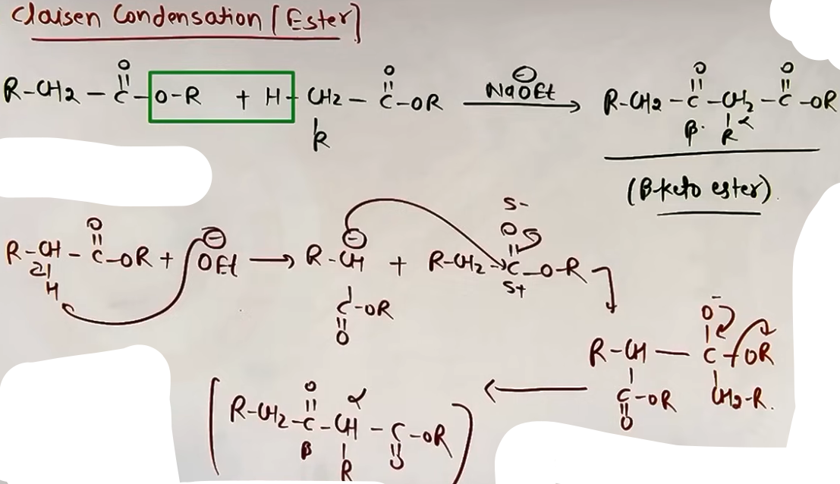
---
PROBLEM-SOLVING FRAMEWORK
Question Type | Identification Clues | Approach / Strategy
Distinguish Acid | NahCO₃ Solution | Acids give CO₂ effervescence; others don't.
Prepare Benzoic Acid | Alkyl chain on ring | Use KMnO₄/OH⁻; chain length doesn't matter.
Predict Acidity | EWG/EDG substituents | EWG = More Acidic; EDG = Less Acidic.
HVZ Product | X₂ / Red P | Substitute one Br/Cl at the alpha-carbon.
Decarboxylation | Beta-keto structure | Simply remove CO₂ and join R to CH₃.
Identify Catalyst | Pd-BaSO₄ vs NaOH/CaO | Rosenmund makes Aldehyde; Soda lime makes Alkane.

COMMON MISTAKES AND TRAPS
Mistake | Why Students Make It | Correct Approach / Thinking
Oxidizing t-butyl benzene | Applying KMnO₄ rule blindly. | Need benzylic hydrogen; t-butyl has none.
HVZ on Benzoic Acid | Assuming any acid reacts. | Need alpha-H; Benzoic acid has no alpha-H.
Esterification H/OH source | Standard H₂O removal logic. | -OH comes from Acid; -H from Alcohol.
Kolbe's for Methane | Forgetting R-R coupling. | Methane needs 1 carbon; Kolbe's gives even R-R.
NaHCO₃ with Phenol | Thinking all organics react. | Only acids and Nitrophenols react with NaHCO₃.
FINAL FORMULA SHEET
PREPARATION
- Alkylbenzene Oxidation: Ar-R + KMnO₄/OH⁻ -> Ar-COOH
- Nitrile Hydrolysis: R-CN + 2H₂O + H⁺ -> R-COOH + NH₄⁺
- Grignard + CO₂: R-MgX + CO₂ -> R-COOH
- Koch Reaction: Alkene + CO + H₂O -> R-COOH

REACTIONS
- Esterification: RCOOH + R'OH ⇌ RCOOR' + H₂O
- HVZ: R-CH₂-COOH + X₂/Red P -> R-CH(X)-COOH
- Soda Lime: R-COONa + NaOH (CaO) -> R-H + Na₂CO₃
- Kolbe's: 2R-COONa + 2H₂O -> R-R + 2CO₂ + H₂ + 2NaOH
- Thallimide Heating: Phthalic Acid + NH₃ -> Phthalimide

ULTRA-QUICK REVISION

- Carbonyl carbon in acids is LESS electrophilic than aldehydes/ketones.
- Carboxylic acids dimerize in vapor phase via H-bonding.
- EWG stabilizes carboxylate ion -> Higher acidity.
- Ortho-substituted benzoic acids are always more acidic (Ortho Effect).
- HVZ reaction requires alpha-hydrogen and Red P catalyst.
- Beta-keto acids decarboxylate on simple heating.
- Reactivity: Acid Chloride > Anhydride > Ester > Amide.
- NaHCO₃ test is specific for carboxylic acids (effervescence).
- SOCl₂ is best for making acid chlorides (gaseous by-products).
- Grignard + CO₂ adds exactly one carbon to the original R group.

